

**CAPSTONE PROJECT REPORT**

**Report 3 – Software Requirement Specification**

– HoChiMinh, September 2020 –

**Table of Contents**

I. Project Report 6

1. Status Report 6

2. Team Involvements 6

3. Issues/Suggestions 6

4. 状況報告 6

5. チーム-関与事項 7

6. 課題/提案 7

II. Software Requirement Specification 8

1. Overall Description 8

1.1 Product Overview 8

1.2 Business Rules 8

2. User Requirements 9

2.1 Overview 9

a. Use Case Diagram 9

b. System Actors 9

c. Use Cases List 9

2.2 List of use case 11

2.2.1 <Guest> Overview use case 11

2.2.2 <Customer> Overview use case 16

2.2.3 <Photographer> Overview Use Case 35

2.2.4 <Authenticated User> Overview Use Case 54

2.2.5 <Admin> Overview Use Case 61

2.2.6 <<system>>Handler Overview use case 77

3. Functional Requirements 82

3.1 System Functional Overview 82

a. Screen Flow 82

b. Screen Details 85

c. Screen Authorization 88

d. Non-Screen Functions 89

e. Entity Relationship Diagram 90

4. Non-Functional Requirements 91

4.1 External Interfaces 91

a. User Interfaces 91

b. Software Interfaces 91

c. Hardware Interfaces 91

d. Communications Interfaces 91

4.2 Quality Attributes 92

a. Usability 92

b. Reliability 92

c. Performance 92

d. Dependability 92

e. Supportability 92

f. Design Constraints 92

g. Support Documents 92

h. Purchased Components 93

5. Other Requirements 93

5.1 Messages List 93

**List of Figures**

Figure 1 Context Diagram 8

Figure 2 Overview Use Case Diagram 9

Figure 3 <Guest> Overview 11

Figure 4 <Guest> Register 12

Figure 5 <Guest> Login 14

Figure 6 <Customer> Overview 16

Figure 7 <Customer> Search photographers 17

Figure 8 <Customer> Get photographer's detail 18

Figure 9 <Customer> Book photographer 19

Figure 10 <Customer> Review photographers 21

Figure 11 <Customer> Get booking 23

Figure 12 <Customer> Edit booking 24

Figure 13 <Customer> Cancel booking 26

Figure 14 <Customer> Open thread 28

Figure 15<Customer> Edit thread 29

Figure 16 <Customer> Comment thread 31

Figure 17 <Customer> Chat 33

Figure 18 <Photographer> Overview 35

Figure 19 <Photographer> Accept booking 36

Figure 20 <Photographer> Decline booking 37

Figure 21 <Photographer> Edit working weekdays 39

Figure 22 <Photographer> Add busy day 41

Figure 23 <Photographer> Get customer's review 42

Figure 24 <Photographer> Add package 43

Figure 25<Photographer> Edit package 45

Figure 26 <Photographer> Remove package 47

Figure 27 <Photographer> Add album 49

Figure 28 <Photographer> Edit album 51

Figure 29 <Photographer> Remove album 53

Figure 30 <Authenticated User> Overview 54

Figure 31 <Authenticated User> Get profile 55

Figure 32 <Authenticated User> Edit profile 56

Figure 33 <Authenticated User> Change password 57

Figure 34 <Authenticated User> Logout 59

Figure 35 <Admin> Overview 61

Figure 36 <Admin> Block user 62

Figure 37 <Admin> Unblock user 63

Figure 38 <Admin> Add category 65

Figure 39 <Admin> Edit category 66

Figure 40 <Admin> Remove category 68

Figure 41 <Admin> Add returning type 69

Figure 42 <Admin> Edit returning type 71

Figure 43 <Admin> Remove returning type 73

Figure 44 <Admin> Change variables 74

Figure 45<Admin> Ban thread 76

Figure 46 <System Handler> Overview 77

Figure 47 <System Handler> Make booking notification 78

Figure 48 <System Handler> Make scheduling notification 79

Figure 49 <System Handler> Make weather warning 80

Figure 50 <System Handler> Make time warning 81

Figure 51 Customer's screen flow 83

Figure 52 Photographer's screen flow 84

Figure 53 Screen authorization 89

Figure 54 ER Diagram 90

**List of Tables**

Table 1 Business Rules 8

Table 2 System Actors 9

Table 3 Use Case List 11

Table 4 <Guest> Register Specification 14

Table 5 <Guest> Register Specification 15

Table 6 <Customer> Search Photographers Specification 18

Table 7 <Customer> Get photographer's detail specification 19

Table 8 <Customer> Book photographer specification 21

Table 9 <Customer> Review photographers specification 22

Table 10 <Customer> Get booking specification 24

Table 11 <Customer> Edit booking specification 26

Table 12 <Customer> Cancel booking specification 28

Table 13 <Customer> Open thread specification 29

Table 14 <Customer> Edit thread specification 31

Table 15 <Customer> Comment thread specification 33

Table 16 <Customer> Chat specification 34

Table 17 <Photographer> Accept booking specification 37

Table 18 <Photographer> Decline booking specification 39

Table 19 Edit working weekdays specification 40

Table 20 <Photographer> Add busy day specification 42

Table 21<Photographer> Get customer's review specification 43

Table 22 <Photographer> Add package specification 45

Table 23 <Photographer> Edit package specification 47

Table 24 <Photographer> Remove package specification 49

Table 25 <Photographer> Add album specification 50

Table 26 <Photographer> Edit album specification 53

Table 27<Photographer> Remove album specification 54

Table 28 <Authenticated User> Get profile specification 56

Table 29 <Authenticated User> Edit profile specification 57

Table 30 <Authenticated User> Change password specification 59

Table 31 <Authenticated User> Logout specification 60

Table 32 <Admin> Block user specification 63

Table 33 <Admin> Unblock user specification 64

Table 34 <Admin> Add category specification 66

Table 35 <Admin> Edit category specification 68

Table 36 <Admin> Remove category specification 69

Table 37 <Admin> Add returning type specification 71

Table 38 <Admin> Edit returning type specification 72

Table 39 <Admin> Remove returning type specification 74

Table 40 <Admin> Change variables specification 76

Table 41 <Admin> Ban thread specification 77

Table 42 <System Handler> Make booking notification specification 79

Table 43 <System Handler> Make scheduling notification specification 80

Table 44 <System Handler> Make weather warning specification 81

Table 45<System Handler> Make time warning specification 82

Table 46 Customer's screen details 86

Table 47 Photographer's screen details 87

Table 48 Non-screen functions 90

Table 49 Entities List 91

Table 50 Messages List 94

# I. Project Report

## 1. Status Report

|  |  |  |  |
| --- | --- | --- | --- |
| **#** | **Work Item** | **Status** | **Notes (Work Item in Details)** |
| 1 | Overall Description | Completed |  |
| 2 | User Requirements | Completed |  |
| 3 | Functional Requirements | Completed |  |
| 4 | Non-Functional Requirements | Completed |  |
| 5 | Other Requirements | Completed |  |

## 2. Team Involvements

|  |  |  |  |
| --- | --- | --- | --- |
| **#** | **Task** | **Member** | **Notes (Task Details, etc.)** |
| 1 | Overall Description | Kiendst |  |
| 2 | User Requirements | Thaott, Mytn |  |
| 3 | Functional Requirements | Kiendst, Thaott |  |
| 4 | Non-Functional Requirements | Mytn, Datbc |  |
| 5 | Other Requirements | Mytn, Datbc |  |

## 3. Issues/Suggestions

|  |  |  |  |
| --- | --- | --- | --- |
| **#** | **Issue** | **Status** | **Notes (Solution, Suggestion, etc.)** |
|  |  |  |  |

## 4. 状況報告

|  |  |  |  |
| --- | --- | --- | --- |
| **#** | **課題項目** | **状況** | **注意** |
| 1 | 概要説明 | 完成 |  |
| 2 | ユーザー要件 | 完成 |  |
| 3 | 機能要件 | 完成 |  |
| 4 | 非機能要件 | 完成 |  |
| 5 | 他の要件 | 完成 |  |

## 5. チーム-関与事項

|  |  |  |  |
| --- | --- | --- | --- |
| **#** | **課題** | **メンバー** | **注意** |
| 1 | 概要説明 | Kiendst |  |
| 2 | ユーザー要件 | Thaott, Mytn |  |
| 3 | 機能要件 | Kiendst, Thaott |  |
| 4 | 非機能要件 | Mytn, Datbc |  |
| 5 | 他の要件 | Mytn, Datbc |  |

## 6. 課題/提案

|  |  |  |  |
| --- | --- | --- | --- |
| **#** | **課題** | **状況** | **注意** |
|  |  |  |  |

# II. Software Requirement Specification

## 1. Overall Description

### 1.1 Product Overview

Photographer Booking System is a new system that helps users find photographers effectively based on their needs. The context diagram below describes the 1.0 version of the system and external entities that interact with it.

### 1.2 Business Rules

|  |  |
| --- | --- |
| **ID** | **Rule Definition** |
|  |  |

*Table 1 Business Rules*

## 2. User Requirements

### 2.1 Overview

#### a. Use Case Diagram

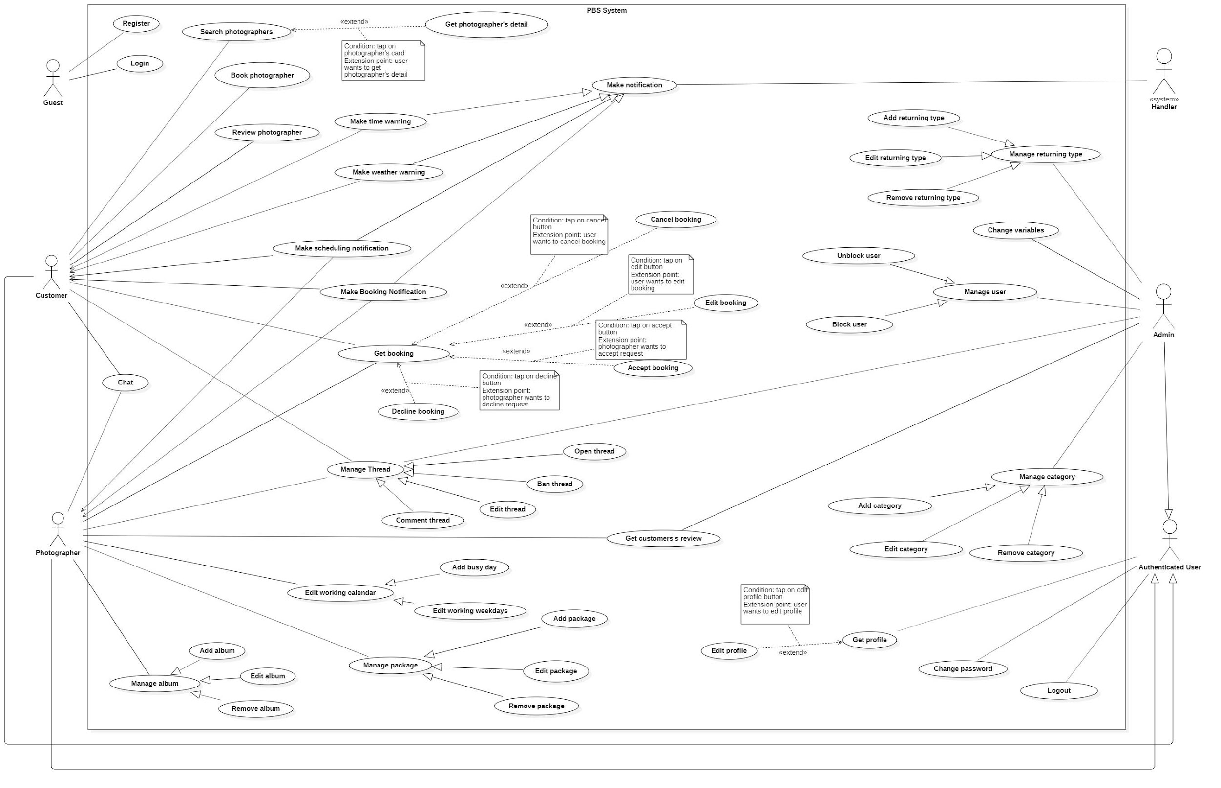

*Figure 2 Overview Use Case Diagram*

#### b. System Actors

|  |  |  |
| --- | --- | --- |
| **No** | **Actor** | **Description** |
| 1 | Administrator | Administrators manage the whole system |
| 2 | Photographer | Photographers offer shooting services and handle customers’ requests |
| 3 | Customer | Customers make bookings to use photographers’ services |
| 4 | Guest | Guests are the ones without accounts |
| 5 | Authenticated User | Authenticated Users are the ones have accounts (admins, photographers, customers) |
| 6 | <<system>> Handler | <<system>> Handler deals with internal processes. |

*Table 2 System Actors*

#### c. Use Cases List

|  |  |  |  |
| --- | --- | --- | --- |
| **No** | **Use Case** | **Primary Actors** | **Secondary Actors** |
| 01 | Register | Guest |  |
| 02 | Login | Guest |  |
| 03 | Search photographers | Customer |  |
| 04 | Get photographer’s detail | Customer |  |
| 05 | Book photographer | Customer |  |
| 06 | Review photographer | Customer |  |
| 07 | Get booking | Customer, Photographer |  |
| 08 | Edit booking | Customer |  |
| 09 | Cancel booking | Customer |  |
| 10 | Accept booking | Photographer |  |
| 11 | Decline booking | Photographer |  |
| 12 | Open thread | Customer, Photographer, Admin |  |
| 13 | Edit thread | Customer, Photographer,  Admin |  |
| 14 | Comment thread | Customer, Photographer, Admin |  |
| 15 | Chat | Customer, Photographer |  |
| 16 | Edit working weekdays | Photographer |  |
| 17 | Add busy day | Photographer |  |
| 18 | Get customer’s review | Photographer, Admin |  |
| 19 | Add package | Photographer |  |
| 20 | Edit package | Photographer |  |
| 21 | Remove package | Photographer |  |
| 22 | Add album | Photographer |  |
| 23 | Edit album | Photographer |  |
| 24 | Remove album | Photographer |  |
| 25 | Get profile | Authenticated User |  |
| 26 | Edit profile | Authenticated User |  |
| 27 | Change password | Authenticated User |  |
| 28 | Logout | Authenticated User |  |
| 29 | Block user | Admin |  |
| 30 | Unblock user | Admin |  |
| 31 | Add category | Admin |  |
| 32 | Edit category | Admin |  |
| 33 | Remove category | Admin |  |
| 34 | Add returning type | Admin |  |
| 35 | Edit returning type | Admin |  |
| 36 | Remove returning type | Admin |  |
| 37 | Change variables | Admin |  |
| 38 | Ban thread | Admin |  |
| 39 | Make booking notification | System Handler |  |
| 40 | Make scheduling notification | System Handler |  |
| 41 | Make weather warning | System Handler |  |
| 42 | Make time warning | System Handler |  |

*Table 3 Use Case List*

### 2.2 List of use case

#### 2.2.1 <Guest> Overview use case

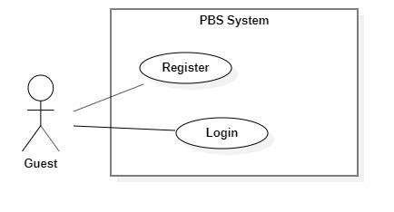

*Figure 3 <Guest> Overview*

##### a. <Guest> Register

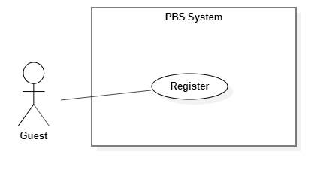

*Figure 4 <Guest> Register*

|  |  |  |  |  |  |
| --- | --- | --- | --- | --- | --- |
| UC ID and Name: | **UC – 01 Register** | | | | |
| Created By: | Trần Thiên Thảo | | Date Created: | 08/10/2020 | |
| Primary Actor: | Guest | | Secondary Actors: |  | |
| Trigger: | The Guest sends a request to register an account. | | | | |
| Description: | This use case allows Guest to register an account in the system. | | | | |
| Preconditions: | User is not logged in. | | | | |
| Post-conditions: | **Success:** Guest successfully registered an account.  **Fail:** System shows error message. | | | | |
| Normal Flow: | **Step** | **Actor Action** | | | **System Response** |
| 1 | Guest goes to register view | | | System requires information from Guest:  - “Họ và tên”: text input, required.  - “Tên đăng nhập”: text input, required  - “Mật khẩu”: password input, required.  - “Xác nhận mật khẩu”: password input, required.  - “Số điện thoại”: phone number input.  - “Email”: text input, required. |
| 2 | Guest inputs required information | | |  |
| 3 | Guest send request to register in the system | | | The system validates data, outputs message “Đăng ký thành công”  [Exception 1]  [Exception 2]  [Exception 3]  [Exception 4] |
| Alternative Flows: | N/A | | | | |
| Exceptions: | **No** | **Cause** | | | **System Response** |
| 1 | Required fields are empty. | | | System shows error message:  “Thông tin này là bắt buộc” |
| 2 | Password and confirm password are not matched. | | | System shows error message:  “Mật khẩu không khớp”. |
| 3 | Required fields are not valid. | | | System shows error message corresponds to the field:  “Tên đăng nhập không đúng”  “Email không đúng”  “Mật khẩu chưa đủ mạnh” |
| 4 | Required information exists in the system (username, email). | | | System shows error message corresponds to the field:  “Tên đăng nhập đã có người sử dụng. Vui lòng nhập tên khác.”  “Email đã tồn tại.” |
| Priority: | Medium | | | | |
| Frequency of Use: | Usually | | | | |
| Business Rules: | * Needed information are: username, password, phone number, email, full name. * Username format should be 8-20 characters long, starts with character and underscore or dot can’t be at the end or beginning. * Password format should be a minimum eight characters, contains at least one number, one letter and one special character. * Encrypt password using SHA256 hash function. * Email format should match regex: ^\w+@[a-zA-Z_]+?\.[a-zA-Z]{2,3}$ * Phone should be in Vietnamese format. * All information must not be empty when submit. * After registering successfully, navigate back to login view. | | | | |
| Other Information: | N/A | | | | |
| Assumptions: | N/A | | | | |

*Table 4 <Guest> Register Specification*

##### b. <Guest> Login

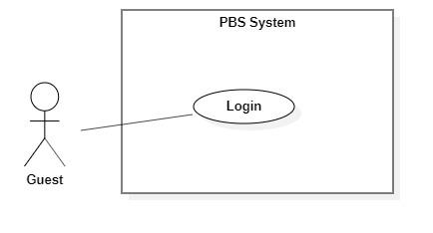

*Figure 5 <Guest> Login*

|  |  |  |  |  |  |
| --- | --- | --- | --- | --- | --- |
| UC ID and Name: | **UC – 02 Login** | | | | |
| Created By: | Trần Thiên Thảo | | Date Created: | 08/10/2020 | |
| Primary Actor: | Guest | | Secondary Actors: |  | |
| Trigger: | The Guest sends a request to login into the system. | | | | |
| Description: | This use case allows Guest to login into the system. | | | | |
| Preconditions: | User is not logged in. | | | | |
| Post-conditions: | **Success**: Guest successfully logged into the system.  **Fail:** System shows error message. | | | | |
| Normal Flow: | **Step** | **Actor Action** | | | **System Response** |
| 1 | Guest goes to login view | | | System requires information from Guest:  - “Tên đăng nhập”: text input, required  - “Mật khẩu”: password input, required |
| 2 | Guest inputs required information | | |  |
| 3 | Guest sends request to login into the system | | | System validates data, outputs message “Đăng nhập thành công”  [Exception 1]  [Exception 2] |
| Alternative Flows: | N/A | | | | |
| Exceptions: | **No** | **Cause** | | | **System Response** |
| 1 | Required fields are empty | | | System shows error message: “Thông tin này là bắt buộc” |
| 2 | Username or password is incorrect | | | System shows error message: “Thông tin đăng nhập không chính xác” |
| Priority: | Medium | | | | |
| Frequency of Use: | Usually | | | | |
| Business Rules: | * User login using username and password. * Username and password format match with the one they have registered. * Encrypt password to SHA256 and compare to password in database. * New Json web token will be returned to client side. * New user session will be created. * After login successfully, navigate user to Home view. | | | | |
| Other Information: | N/A | | | | |
| Assumptions: | N/A | | | | |

*Table 5 <Guest> Register Specification*

#### 2.2.2 <Customer> Overview use case

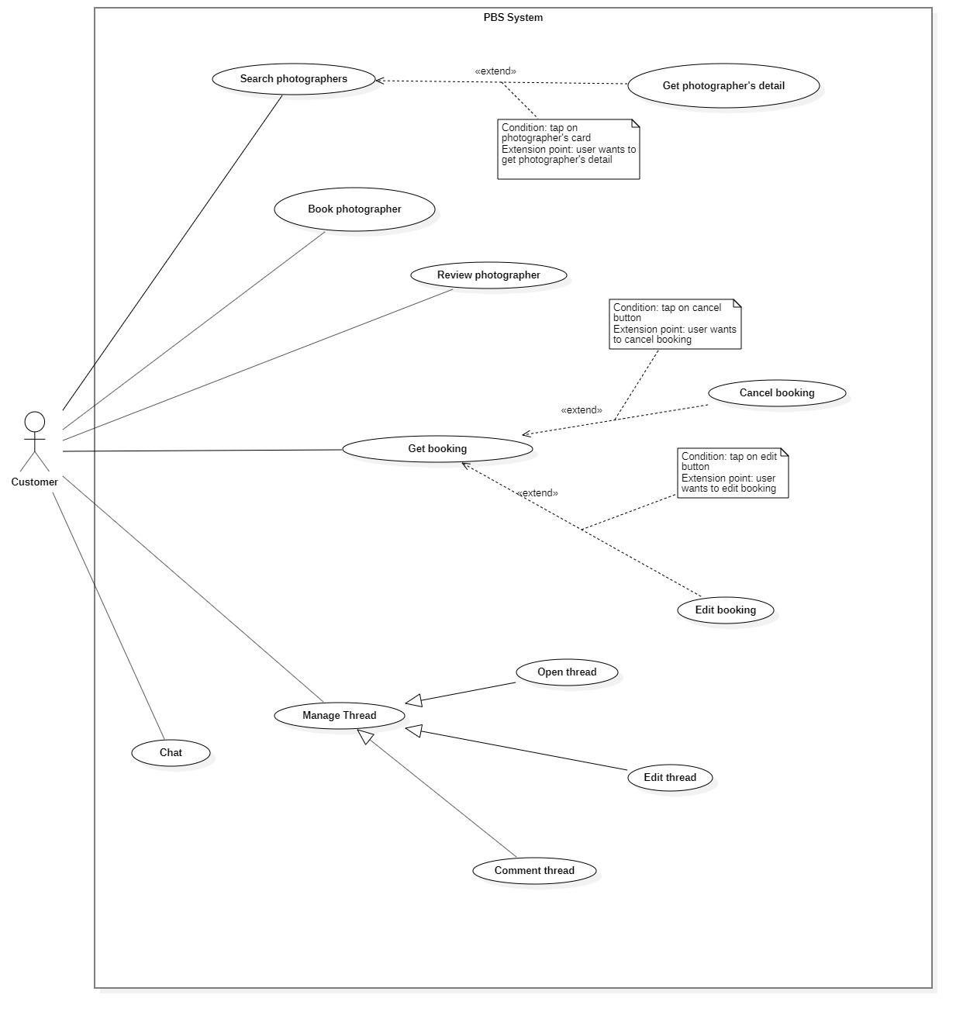

*Figure 6 <Customer> Overview*

##### <Customer> Search photographer

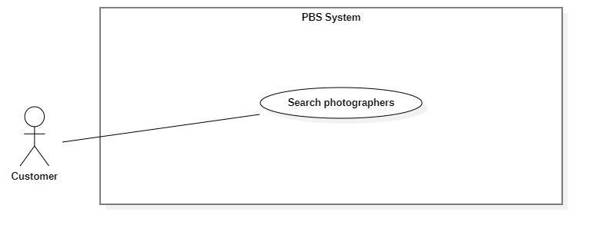

*Figure 7 <Customer> Search photographers*

|  |  |  |  |  |  |
| --- | --- | --- | --- | --- | --- |
| UC ID and Name: | **UC – 03 Search photographers** | | | | |
| Created By: | Trần Thiên Thảo | | Date Created: | 08/10/2020 | |
| Primary Actor: | Customer | | Secondary Actors: |  | |
| Trigger: | The customer sends a request to find photographers. | | | | |
| Description: | This use case allows customers to find photographers and also packages. | | | | |
| Preconditions: | User must be authenticated as Customer. | | | | |
| Post-conditions: | **Success**: A list of photographers is shown.  **Fail**: System shows error messages. | | | | |
| Normal Flow: | **Step** | **Actor Action** | | | **System Response** |
| 1 | Customer goes to photographers searching view. | | | System requires information from Guest:  - “Tìm kiếm”: text input. |
| 2 | Customer inputs information. | | |  |
| 3 | Customer sends request to search photographers. | | | System displays list of photographers and packages.  [Exception 1] |
| Alternative Flows: | N/A | | | | |
| Exceptions: | **No** | **Cause** | | | **System Response** |
| 1 | The process runs into an internal error. | | | System shows error message: “Đã có lỗi xảy ra”. |
| Priority: | Medium | | | | |
| Frequency of Use: | Sometimes | | | | |
| Business Rules: | * User inputs text in search field, system returns photographers’ name and packages’ name contains the text. * The list of photographers will be ordered by rating count. * List of photographers is shown with following information: name, avatar, rating count. * List of packages is shown with following information: name, price, description, photographer’s name. * If the list is empty, return empty text to customer. | | | | |
| Other Information: | N/A | | | | |
| Assumptions: | N/A | | | | |

*Table 6 <Customer> Search Photographers Specification*

##### <Customer> Get photographer’s detail

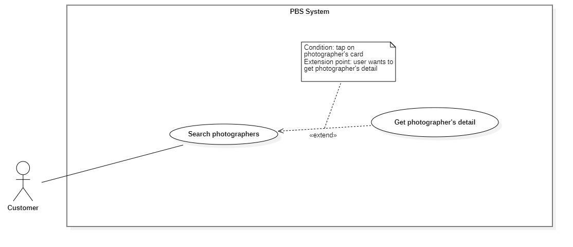

*Figure 8 <Customer> Get photographer's detail*

|  |  |  |  |  |  |
| --- | --- | --- | --- | --- | --- |
| UC ID and Name: | **UC – 04 Get photographer’s detail** | | | | |
| Created By: | Trần Thiên Thảo | | Date Created: | 08/10/2020 | |
| Primary Actor: | Customer | | Secondary Actors: |  | |
| Trigger: | The customer sends a request to get the photographer's details. | | | | |
| Description: | This use case allows customers to get photographer’s detail. | | | | |
| Preconditions: | User has been authenticated as a Customer. | | | | |
| Post-conditions: | **Success:** The system displays the photographer’s detail.  **Fail:** The system shows error message | | | | |
| Normal Flow: | **Step** | **Actor Action** | | | **System Response** |
| 1 | Customer sends request to get photographer’s detail. | | | System returns photographer’s detail  [Exception 1] |
| Alternative Flows: | N/A | | | | |
| Exceptions: | No | Cause | | | System Response |
| 1 | The process runs into an internal error. | | | System shows error message: “Đã có lỗi xảy ra” |
| Priority: | Medium | | | | |
| Frequency of Use: | Usually | | | | |
| Business Rules: | * The photographer’s detail return contains the following information: photographer’s basic information like rating count, self-description, customers’ reviews, photographer’s working calendar, photographer’s packages. * Photographer working calendar includes the date they have been booked and the date they are busy. * Photographer’s packages contain the following information: package’s name, package’s price, package’s description, package’s services, package’s time anticipation. * If any information is empty, return empty text. | | | | |
| Other Information: | N/A | | | | |
| Assumptions: | N/A | | | | |

*Table 7 <Customer> Get photographer's detail specification*

##### <Customer> Book photographer

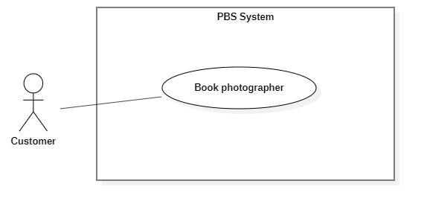

*Figure 9 <Customer> Book photographer*

|  |  |  |  |  |  |
| --- | --- | --- | --- | --- | --- |
| UC ID and Name: | **UC – 05 Book photographer** | | | | |
| Created By: | Trần Thiên Thảo | | Date Created: | 08/10/2020 | |
| Primary Actor: | Customer | | Secondary Actors: |  | |
| Trigger: | The customer sends a request to make a booking. | | | | |
| Description: | This use case allows customers to make a booking for photographers. | | | | |
| Preconditions: | - Users must login into the system with the role Customer.  - The photographer must exist in the system with status as “active”. | | | | |
| Post-conditions: | **Success:** A booking will be stored with status is “Pending” **Fail:** System outputs error message and sends to Customer. | | | | |
| Normal Flow: | **Step** | **Actor Action** | | | **System Response** |
| 1 | The customer goes to booking view | | | System returns the available photographer’s detail.  System requires information from customers:  - “Thời gian chụp”: date time picker, required  - “Thời gian nhận ảnh”: date time picker, required  - “Địa điểm”: map picker, required  - “Phương thức nhận ảnh”: dropdownlist, required,  - “Gói dịch vụ: drop down list, required  - “Tổng cộng”: text |
| 2 | The customer inputs required information and send request to create new booking | | | - The system validates data  - The system adds new booking to the system, outputs “Đặt hẹn thành công” and send to photographer.  [Exception 1]  [Exception 2] |
| Alternative Flows: | N/A | | | | |
| Exceptions: | **No** | **Cause** | | | **System Response** |
| 1 | The customer inputs invalid data or leaves empty required fields | | | System outputs error message and send request to ask Customer to input correctly |
| 2 | The process run into an internal error | | | Error will be recorded in a log file. System outputs error message to customer. |
| Priority: | Medium | | | | |
| Frequency of Use: | Usually | | | | |
| Business Rules: | - Booking will be managed by the system with following status: Pending, Ongoing, Editing, Done, Rejected, Cancelled.  - Booking information contains: package’s details, time and location details, editing deadline, photographer’s detail, customer’s detail, returning type.  - Package’s detail contains: package’s name, package’s price, package’s services.  - Time and location detail contain: shooting date and time, shooting location.  - Photographer’s detail: photographer’s name.  - Customer’s detail: customer’s name, customer’s phone.  - Photographer returned by the system will contain: photographer’s information, photographer’s package detail.  - All information must not be empty.  - Editing deadline must be after shooting time at least 1 day.  - After booking successfully, a new booking will have “Pending” status.  - If booking is failed, return fail message. | | | | |
| Other Information: | N/A | | | | |
| Assumptions: | N/A | | | | |

*Table 8 <Customer> Book photographer specification*

##### <Customer> Review photographers

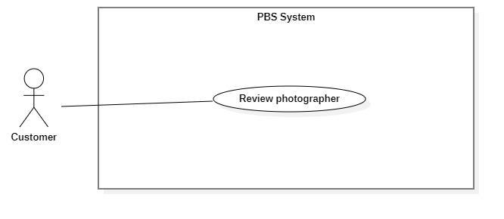

*Figure 10 <Customer> Review photographers*

|  |  |  |  |  |  |
| --- | --- | --- | --- | --- | --- |
| UC ID and Name: | **UC – 06 Review photographer** | | | | |
| Created By: | Trần Thiên Thảo | | Date Created: | 08/10/2020 | |
| Primary Actor: | Customer | | Secondary Actors: |  | |
| Trigger: | The customer sends a request to review photographer. | | | | |
| Description: | This use case allows customers to review photographer after booking is done. | | | | |
| Preconditions: | - User has been authenticated as Customer  - Booking status is “Đã hoàn thành” | | | | |
| Post-conditions: | **Success:** The review will be stored in the system and response message to Customer.  **Fail:** System shows error message. | | | | |
| Normal Flow: | **Step** | **Actor Action** | | | **System Response** |
| 1 | The customer goes to review view | | | System requires information from Customer:  - “Bình luận của bạn”: text  - “Đánh giá dịch vụ”: slider |
| 2 | The customer inputs information and sends requests | | | System creates new review and outputs message: “Đã gửi bình luận”  [Exception 1]  [Exception 2] |
|  |  | | |  |
| Alternative Flows: | N/A | | | | |
| Exceptions: | **No** | **Cause** | | | **System Response** |
| 1 | Customer inputs more than 150 characters for comment | | | System outputs error message: “Đã vượt quá 150 ký tự” |
| 2 | The process run into internal error | | | System outputs error message: “Đã có lỗi xảy ra” |
| Priority: | Medium | | | | |
| Frequency of Use: | Sometimes | | | | |
| Business Rules: | - The customer can only review if a booking state is “DONE”.  - The review contains of comment and rating.  - Rating is double value from 0 to 5.  - Customer can edit their rating. | | | | |
| Other Information: | N/A | | | | |
| Assumptions: | N/A | | | | |

*Table 9 <Customer> Review photographers specification*

##### <Customer> Get booking

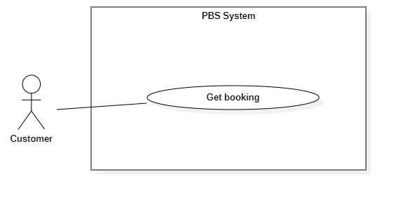

*Figure 11 <Customer> Get booking*

|  |  |  |  |  |  |
| --- | --- | --- | --- | --- | --- |
| UC ID and Name: | **UC – 07 Get booking** | | | | |
| Created By: | Trần Thiên Thảo | | Date Created: | 08/10/2020 | |
| Primary Actor: | Customer, Photographer | | Secondary Actors: |  | |
| Trigger: | Customer or Photographer sends a request to get a booking list. | | | | |
| Description: | This use case allows customers or photographers to get their booking list of all status. | | | | |
| Preconditions: | User has been authenticated as Customer / Photographer | | | | |
| Post-conditions: | **Success:** System displays list of bookings.  **Fail:** System shows error message. | | | | |
| Normal Flow: | Step | Actor Action | | | System Response |
| 1 | Customer / Photographer sends a request to get a list of bookings. | | | System returns list of bookings.  [Exception 1] |
| Alternative Flows: | N/A | | | | |
| Exceptions: | No | Cause | | | System Response |
| 1 | System run into internal error | | | System shows error message: “Đã có lỗi xảy ra” |
| Priority: | Medium | | | | |
| Frequency of Use: | Usually | | | | |
| Business Rules: | - The list of bookings is displayed and ordered by most recent activity (System will save the time of every activity like accepting, cancelling, rejecting, etc..).  - Booking has following status:   * Pending * Ongoing * Editing * Done * Rejected * Cancelled   - Booking has following information: Name of the person who booked, time details (Datetime), location details, booking status, booked package.  - Time details have following information: shooting date, start time, end time, edit deadline, shooting time anticipated.  - Location details have following information: location name, location’s latitude and longitude.  - Package has following information: package’s name, package’s price, package’s services. | | | | |
| Other Information: | N/A | | | | |
| Assumptions: | N/A | | | | |

*Table 10 <Customer> Get booking specification*

##### <Customer> Edit Booking

|  |  |  |  |  |  |
| --- | --- | --- | --- | --- | --- |
| UC ID and Name: | **UC – 08 Edit booking** | | | | |
| Created By: | Trần Thiên Thảo | | Date Created: | 08/10/2020 | |
| Primary Actor: | Customer | | Secondary Actors: |  | |
| Trigger: | The Customer sends a request to edit booking. | | | | |
| Description: | This use case allows customers to edit their booking. | | | | |
| Preconditions: | The User has been authenticated as Customer. | | | | |
| Post-conditions: | **Success:** Booking successfully edited and saved to the system.  **Fail:** System shows error message. | | | | |
| Normal Flow: | **Step** | **Actor Action** | | | **System Response** |
| 1 | Customer sends request to receive booking detail | | | System returns booking detail with following information:  - “Trạng thái”: text  - “Thời gian”: text  - “Thời gian tác nghiệp dự kiến”: text  - “Thời gian trả ảnh”: text  - “Địa điểm”: map  - “Thông tin khách hàng”:   * “Tên khách hàng”: text   - “Tên gói dịch vụ”:   * “Tên gói”: text * “Mô tả”: text * “Giá dịch vụ: text * “Dịch vụ”: list of texts   [Exception 1] |
|  | Customer inputs information and sends request to edit booking | | | System outputs message: “Bạn muốn thay đổi thông tin cuộc hẹn này?” |
|  | Customer confirm “Có”  [Alternative 1] | | | - The system validates data  - The system adds new booking to the system, outputs “Cập nhật thành công” and send to photographer.  [Exception 2]  [Exception 3] |
| Alternative Flows: | **Step** | **Actor Action** | | | **System Response** |
| 1 | Customer confirm “Không” | | | Back to booking detail view |
| Exceptions: | **No** | **Cause** | | | **System Response** |
| 1 | System can’t get the booking detail | | | System show error message: “Không tìm thấy cuộc hẹn” |
| 2 | The customer inputs invalid data or leaves empty required fields | | | System outputs error message and send request to ask Customer to input correctly |
| 3 | The process runs into an internal error. | | | Error will be recorded in a log file. System outputs error message to customer. |
| Priority: | Medium | | | | |
| Frequency of Use: | Sometimes | | | | |
| Business Rules: | * Customer can only edit the booking if its status is “Pending”. * Customer can edit information like shooting time, shooting location, package, returning type and send request to photographer. * All information must not be empty. * Editing deadline must be after shooting time at least 1 day. * After edit, save editing time to the system. * After edit successfully, sends notification to the photographer. | | | | |
| Other Information: | N/A | | | | |
| Assumptions: | N/A | | | | |

*Table 11 <Customer> Edit booking specification*

##### <Customer> Cancel booking

|  |  |  |  |  |  |
| --- | --- | --- | --- | --- | --- |
| UC ID and Name: | **UC – 09 Cancel booking** | | | | |
| Created By: | Trần Thiên Thảo | | Date Created: | 08/10/2020 | |
| Primary Actor: | Customer, Photographer | | Secondary Actors: |  | |
| Trigger: | Customer or Photographer sends a request to cancel booking. | | | | |
| Description: | This use case allows customers or photographers to cancel their booking. | | | | |
| Preconditions: | The User has been authenticated as Customer / Photographer. | | | | |
| Post-conditions: | **Success:** The customer cancels booking successfully.  **Fail:** System shows error message | | | | |
| Normal Flow: | **Step** | **Actor Action** | | | **System Response** |
| 1 | Customer sends request to receive booking detail | | | System returns booking detail with following information:  - “Trạng thái”: text  - “Thời gian”: text  - “Thời gian tác nghiệp dự kiến”: text  - “Thời gian trả ảnh”: text  - “Địa điểm”: map  - “Thông tin khách hàng”:   * “Tên khách hàng”: text   - “Tên gói dịch vụ”:   * “Tên gói”: text * “Mô tả”: text * “Giá dịch vụ: text * “Dịch vụ”: list of texts   [Exception 1] |
| 2 | Customer sends request to cancel booking | | | System outputs message: “Bạn muốn hủy cuộc hẹn này?” |
| 3 | Customer confirm “Có” and inputs cancelling reasons to cancel booking  [Alternative 1] | | | System outputs message: “Đã hủy cuộc hẹn”  [Exception 2] |
| Alternative Flows: | **Step** | **Actor Action** | | | **System Response** |
| 1 | Customer confirm “Không” | | | Back to booking detail view |
| Exceptions: | **No** | **Cause** | | | **System Response** |
| 1 | System can’t get the booking detail | | | System show error message: “Không tìm thấy cuộc hẹn” |
| 2 | The process run into an internal error | | | System show error message: “Đã có lỗi xảy ra” |
| Priority: | Medium | | | | |
| Frequency of Use: | Sometimes | | | | |
| Business Rules: | * Customers or Photographers can cancel if status is PENDING, ONGOING, EDITING. * When cancels, get the cancellation reason and save to system. * After cancelling, the status will be Cancelled. * After cancelling, increase the cancellation rate of the user. * After one side cancels, notification will be sent to the other person. | | | | |
| Other Information: | N/A | | | | |
| Assumptions: | N/A | | | | |

*Table 12 <Customer> Cancel booking specification*

##### <Customer> Open thread

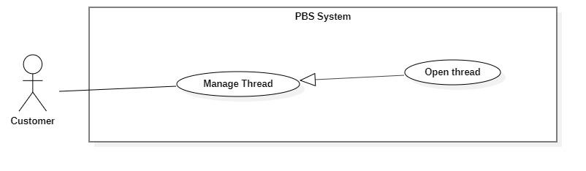

|  |  |  |  |  |  |
| --- | --- | --- | --- | --- | --- |
| UC ID and Name: | **UC – 12 Open thread** | | | | |
| Created By: | Trương Ngọc Mỹ | | Date Created: | 08/10/2020 | |
| Primary Actor: | Customer, Photographer, Admin | | Secondary Actors: |  | |
| Trigger: | User sends a request to open a thread. | | | | |
| Description: | This use case allows users to open new threads on forums. | | | | |
| Preconditions: | The User has been authenticated. | | | | |
| Post-conditions: | **Success:** A new thread will be stored in the system.  **Fail:** System outputs error message. | | | | |
| Normal Flow: | **Step** | **Actor Action** | | | **System Response** |
| 1 | User goes to a new thread view. | | | Systems requires information from Customer:  - “Chủ đề”: combo box, required  - “Tiêu đề”: text, required  - “Nội dung”: text, required  - “Hình ảnh”: image picker |
| 2 | The User inputs required information and sends a request to open a new thread. | | | System validates information, add new thread to the system, outputs message “Đã tạo bài viết mới”  [Exception 1]  [Exception 2] |
| Alternative Flows: | N/A | | | | |
| Exceptions: | **No** | **Cause** | | | **System Response** |
| 1 | User inputs information incorrectly | | | System outputs error message corresponds to data fields:  “Bạn chưa chọn chủ đề”  “Tiêu đề không thể để trống”  “Nội dung đã vượt quá 250 ký tự” |
| 2 | The process runs into an internal error. | | | System outputs error message: “Đã có lỗi xảy ra” |
| Priority: | Medium | | | | |
| Frequency of Use: | Sometimes | | | | |
| Business Rules: | * Needed information are: thread’s name, thread’s content, thread’s topic. * User inputs thread’s name and content as text. * Thread’s topic will be picked from topic option list. | | | | |
| Other Information: | N/A | | | | |
| Assumptions: | N/A | | | | |

*Table 13 <Customer> Open thread specification*

##### <Customer> Edit thread

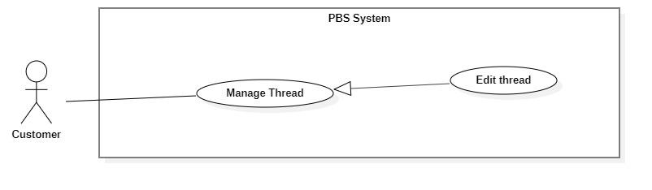

*Figure 15<Customer> Edit thread*

|  |  |  |  |  |  |
| --- | --- | --- | --- | --- | --- |
| UC ID and Name: | **UC – 13 Edit thread** | | | | |
| Created By: | Trương Ngọc Mỹ | | Date Created: | 08/10/2020 | |
| Primary Actor: | Customer, Photographer, Admin | | Secondary Actors: |  | |
| Trigger: | User sends a request to edit the thread. | | | | |
| Description: | This use case allows users to edit their thread. | | | | |
| Preconditions: | - The User has been authenticated. | | | | |
| Post-conditions: | **Success:** Thread will be updated in the system with new content.  **Fail:** System shows error message. | | | | |
| Normal Flow: | **Step** | **Actor Action** | | | **System Response** |
| 1 | User sends request to receive thread detail. | | | System return thread detail with following information:  - “Chủ đề”: combo box, required  - “Tiêu đề”: text, required  - “Nội dung”: text, required  - “Hình ảnh”: image picker  System requires information from customer:  - “Chủ đề”: combo box, required  - “Tiêu đề”: text, required  - “Nội dung”: text, required  - “Hình ảnh”: image picker  [Exception 1] |
| 2 | The user inputs required information and sends a request to edit the thread. | | | System outputs “Bạn muốn cập nhật bài viết này?” |
| 3 | User confirms “Có”  [Alternative 1] | | | System validates information, update thread to the system, outputs message “Đã cập nhật bài viết”  [Exception 2]  [Exception 3] |
| Alternative Flows: | **No** | **Actor Action** | | | **System Response** |
| 1 | User confirms “Không” | | | Back to thread detail view |
| Exceptions: | **Step** | **Cause** | | | **System Response** |
| 1 | System can’t get thread detail | | | System outputs “Không tìm được bài viết” |
| 2 | User inputs information incorrectly | | | System outputs error message corresponds to data fields:  “Bạn chưa chọn chủ đề”  “Tiêu đề không thể để trống”  “Nội dung đã vượt quá 250 ký tự” |
| 3 | The process runs into an internal error. | | | System outputs error message: “Đã có lỗi xảy ra” |
| Priority: | Medium | | | | |
| Frequency of Use: | Sometimes | | | | |
| Business Rules: | * User can edit thread no matter how long they have posted it. * User can edit every information they have posted. Like thread’s name, thread’s content. * After edit successfully, save the datetime of editing. * User can’t change the topic of the thread. | | | | |
| Other Information: | N/A | | | | |
| Assumptions: | N/A | | | | |

*Table 14 <Customer> Edit thread specification*

##### <Customer> Comment thread

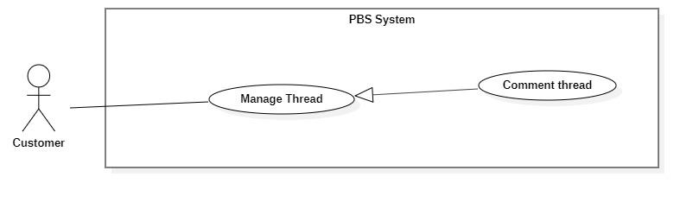

*Figure 16 <Customer> Comment thread*

|  |  |  |  |  |  |
| --- | --- | --- | --- | --- | --- |
| UC ID and Name: | **UC – 14 Comment thread** | | | | |
| Created By: | Trương Ngọc Mỹ | | Date Created: | 08/10/2020 | |
| Primary Actor: | Customer, Photographer, Admin | | Secondary Actors: |  | |
| Trigger: | The user sends a request to the comment thread. | | | | |
| Description: | This use case allows the user to comment on the thread. | | | | |
| Preconditions: | - The User has been authenticated. | | | | |
| Post-conditions: | **Success:** A new comment will be stored in the system.  **Fail:** System shows error message. | | | | |
| Normal Flow: | **Step** | **Actor Action** | | | **System Response** |
| 1 | User sends request to receive thread detail. | | | System return thread detail with following information:  - “Chủ đề”: combo box, required  - “Tiêu đề”: text, required  - “Nội dung”: text, required  - “Hình ảnh”: image picker  System requires information from customer:  - “Bình luận của bạn”: text, required  - “Hình ảnh”: image picker  [Exception 1] |
| 2 | The user inputs required information and sends a request to the comment thread. | | | System outputs “Bạn muốn bình luận bài viết này?” |
| 3 | User confirm “Có”  [Alternative 1] | | | System validates information, add new comment to the system, outputs message “Đã bình luận bài viết”  [Exception 2]  [Exception 3] |
| Alternative Flows: | **No** | **Actor Action** | | | **System Response** |
| 1 | User confirm “Không” | | | Back to thread detail view |
| Exceptions: | **No** | **Cause** | | | **System Response** |
| 1 | System can’t get thread detail | | | System outputs “Không tìm được bài viết” |
| 2 | Customer inputs information incorrectly | | | System outputs error message corresponds to data fields:  “Bình luận đã vượt quá 100 ký tự” |
| 3 | The process runs into an internal error. | | | System outputs error message: “Đã có lỗi xảy ra” |
| Priority: | Medium | | | | |
| Frequency of Use: | Sometimes | | | | |
| Business Rules: | * User inputs comment as text. Length is 350 words. * After the comment is made, notification will be sent to thread owner. | | | | |
| Other Information: | N/A | | | | |
| Assumptions: | N/A | | | | |

*Table 15 <Customer> Comment thread specification*

##### <Customer> Chat

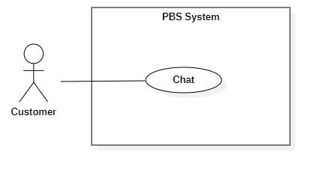

*Figure 17 <Customer> Chat*

|  |  |  |  |  |  |
| --- | --- | --- | --- | --- | --- |
| UC ID and Name: | **UC – 15 Chat** | | | | |
| Created By: | Trương Ngọc Mỹ | | Date Created: | 08/10/2020 | |
| Primary Actor: | Customer, Photographer | | Secondary Actors: |  | |
| Trigger: | Customer or Photographer sends a request to chat. | | | | |
| Description: | This use case allows the users to chat with each other. | | | | |
| Preconditions: | - The User has been authenticated. | | | | |
| Post-conditions: | **Success:** user send message to another user successfully.  **Fail:** System shows error message. | | | | |
| Normal Flow: | **Step** | **Actor Action** | | | **System Response** |
| 1 | User goes to chat view. | | | System return result with following information:   * Photographer’s name: text * Old messages: text   System receives chat input from customer.  [Exception 1] |
| 2 | User inputs messages and send request to chat with photographer. | | | System send messages to photographer and output in chat view.  [Exception 2] |
| Alternative Flows: | N/A | | | | |
| Exceptions: | **No** | **Cause** | | | **System Response** |
| 1 | System can’t get chat view with another user. | | | System outputs “Không tìm được photographer/ Khách hàng” |
| 2 | The process runs into an internal error. | | | System outputs error message: “Đã có lỗi xảy ra” |
| Priority: | Medium | | | | |
| Frequency of Use: | Sometimes | | | | |
| Business Rules: | - Chat view contains following information: Full name of two people who joined, previous messages.  - After a message is sent, notification will be sent to the other person. | | | | |
| Other Information: | N/A | | | | |
| Assumptions: | N/A | | | | |

*Table 16 <Customer> Chat specification*

#### 2.2.3 <Photographer> Overview Use Case

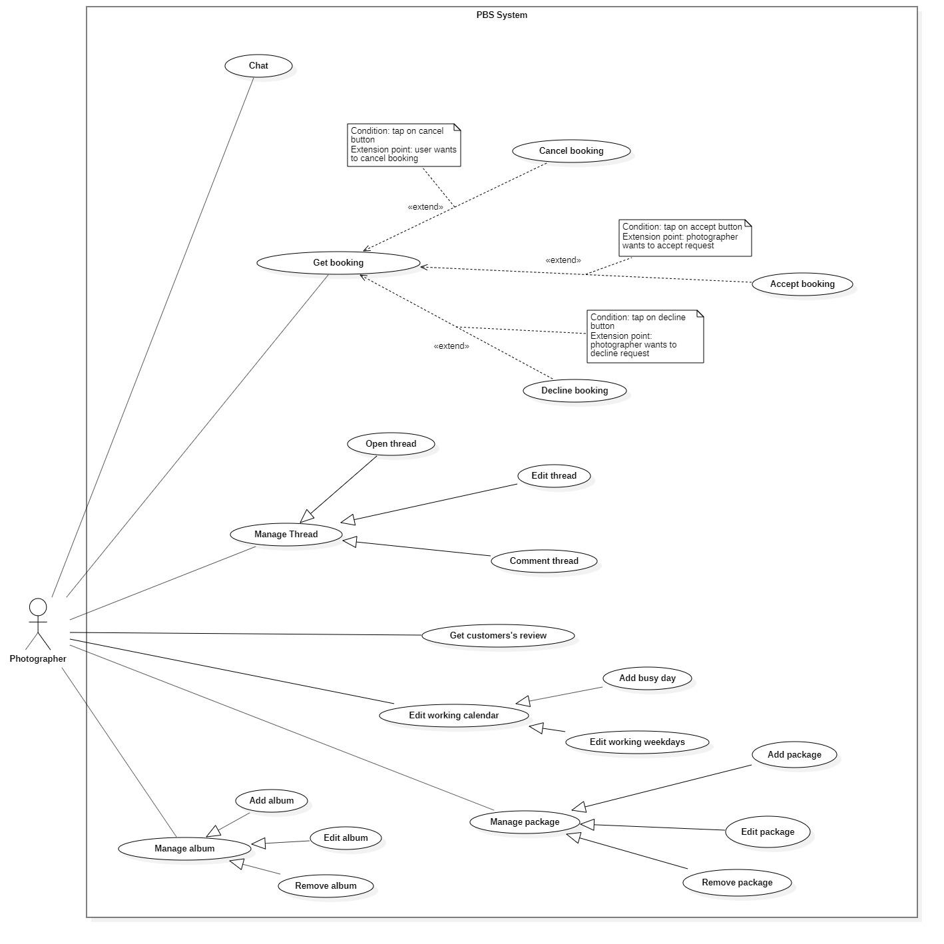

*Figure 18 <Photographer> Overview*

##### <Photographer> Accept Booking

|  |  |  |  |  |  |
| --- | --- | --- | --- | --- | --- |
| UC ID and Name: | **UC – 10 Accept booking** | | | | |
| Created By: | Trần Thiên Thảo | | Date Created: | 08/10/2020 | |
| Primary Actor: | Photographer | | Secondary Actors: |  | |
| Trigger: | The photographer sends a request to accept booking. | | | | |
| Description: | This use case allows photographers to accept booking from customer. | | | | |
| Preconditions: | - User has been authenticated as a Photographer.  - The booking time is still valid. | | | | |
| Post-conditions: | **Success:** The booking will be updated in the system with status change to “Ongoing”  **Fail:** System shows error message | | | | |
| Normal Flow: | **Step** | **Actor Action** | | | **System Response** |
| 1 | Photographer sends request to receive booking details. | | | System returns booking detail with following information:  - “Trạng thái”: text  - “Thời gian”: text  - “Thời gian tác nghiệp dự kiến”: text  - “Thời gian trả ảnh”: text  - “Địa điểm”: map  - “Thông tin khách hàng”:   * “Tên khách hàng”: text   - “Tên gói dịch vụ”:   * “Tên gói”: text * “Mô tả”: text * “Giá dịch vụ: text * “Dịch vụ”: list of texts   [Exception 1] |
| 2 | Photographer sends request to accept booking | | | System outputs: “Chấp nhận cuộc hẹn này?” |
| 3 | Photographer confirms “Có”  [Alternative 1] | | | System outputs: “Nhận cuộc hẹn thành công”  [Exception 2] |
|  |  | | |  |
| Alternative Flows: | **Step** | **Actor Action** | | | **System Response** |
| 1 | Photographer confirm “Không” | | | Back to booking detail view |
| Exceptions: | **No** | **Cause** | | | **System Response** |
| 1 | System can’t get the booking detail | | | System show error message: “Không tìm thấy cuộc hẹn” |
| 2 | The process run into an internal error | | | System show error message: “Đã có lỗi xảy ra” |
| Priority: | Medium | | | | |
| Frequency of Use: | Usually | | | | |
| Business Rules: | * If the booking time of the booking conflicts with old booking, accepting will be fail. Example: Photographer has an Ongoing booking at 9:00 am 20/10/2020, photographer can’t accept another booking at 9:00 am. * After accepting, change status of booking to “Ongoing”. * After photographer accept, notification will be sent to customer. | | | | |
| Other Information: | N/A | | | | |
| Assumptions: | N/A | | | | |

*Table 17 <Photographer> Accept booking specification*

##### <Photographer> Decline Booking

|  |  |  |  |  |  |
| --- | --- | --- | --- | --- | --- |
| UC ID and Name: | **UC – 11 Decline booking** | | | | |
| Created By: | Trương Ngọc Mỹ | | Date Created: | 08/10/2020 | |
| Primary Actor: | Photographer | | Secondary Actors: |  | |
| Trigger: | The photographer sends a request to cancel booking. | | | | |
| Description: | This use case allows photographer to cancel booking from customer | | | | |
| Preconditions: | - The User has been authenticated as a Photographer.  - The booking time is still valid | | | | |
| Post-conditions: | **Success:** The booking will be updated in the system and status change to “Rejected”  **Fail:** System shows error message | | | | |
| Normal Flow: | **Step** | **Actor Action** | | | **System Response** |
| 1 | Photographer sends request to receive booking details. | | | System returns booking detail with following information:  - “Trạng thái”: text  - “Thời gian”: text  - “Thời gian tác nghiệp dự kiến”: text  - “Thời gian trả ảnh”: text  - “Địa điểm”: map  - “Thông tin khách hàng”:   * “Tên khách hàng”: text   - “Tên gói dịch vụ”:   * “Tên gói”: text * “Mô tả”: text * “Giá dịch vụ: text * “Dịch vụ”: list of texts   [Exception 1] |
| 2 | Photographer sends request to decline booking | | | System outputs: “Từ chối cuộc hẹn này?” |
| 3 | Photographer confirms “Có”  [Alternative 1] | | | System outputs: “Đã từ chối cuộc hẹn”  [Exception 2] |
| Alternative Flows: | **Step** | **Actor Action** | | | **System Response** |
| 1 | Photographer confirm “Không” | | | Back to booking detail view |
| Exceptions: | **No** | **Cause** | | | **System Response** |
| 1 | System can’t get the booking detail | | | System show error message: “Không tìm thấy cuộc hẹn” |
| 2 | The process run into an internal error | | | System show error message: “Đã có lỗi xảy ra” |
| Priority: | Usually | | | | |
| Frequency of Use: | Sometimes | | | | |
| Business Rules: | * Photographer can only decline a booking with status “Pending”. * After declined, change booking status to “Rejected”. * When decline, get the rejection reason and save to system. * After photographer decline a booking, notification will be sent to customer. * Decline a booking will increase photographer’s rejection rate, it could be used by admin to supervise photographers. | | | | |
| Other Information: | N/A | | | | |
| Assumptions: | N/A | | | | |

*Table 18 <Photographer> Decline booking specification*

##### <Photographer> Edit working weekdays

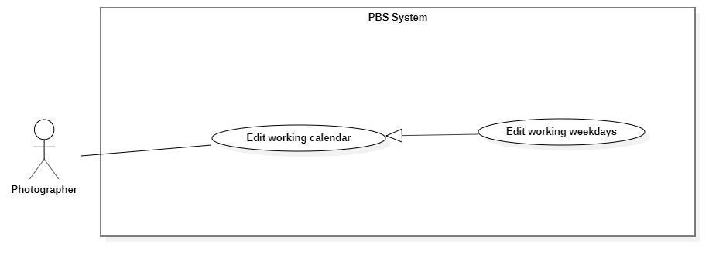

*Figure 21 <Photographer> Edit working weekdays*

|  |  |  |  |  |  |
| --- | --- | --- | --- | --- | --- |
| UC ID and Name: | **UC – 16 Edit working weekdays** | | | | |
| Created By: | Trương Ngọc Mỹ | | Date Created: | 08/10/2020 | |
| Primary Actor: | Photographer | | Secondary Actors: |  | |
| Trigger: | The photographer sends requests to edit working weekdays. | | | | |
| Description: | This use case allows photographers to edit their working weekday. | | | | |
| Preconditions: | The User has been authenticated as a Photographer. | | | | |
| Post-conditions: | **Success:** Photographer’s working weekday will be updated in the system.  **Fail:** System outputs error message. | | | | |
| Normal Flow: | **Step** | **Actor Action** | | | **System Response** |
| 1 | Photographer goes to work weekday editing view. | | | System requires information from photographer:   * “Chọn ngày làm việc”: checkbox |
| 2 | Photographer inputs required information and sends requests to add busy days. | | | System outputs “Xác nhận” |
| 3 | Photographer confirm “Có”  [Alternative 1] | | | System add busy day to system and outputs message “Đã điều chỉnh thời gian làm việc”  [Exception 1]  [Exception 2] |
| Alternative Flows: | **Step** | **Actor Action** | | | **System Response** |
| 1 | Photographer confirms “Không”. | | | Back to working weekday editing view. |
| Exceptions: | **No** | **Cause** | | | **System Response** |
| 1 | The process runs into an internal error | | | System outputs “Đã có lỗi xảy ra” |
| Priority: | Medium | | | | |
| Frequency of Use: | Sometimes | | | | |
| Business Rules: | * Weekday is: Monday, Tuesday, Wednesday, Thursday, Friday, Saturday, Sunday. * Photographer can decide whether or not they want to work on a weekday. A boolean isWorking will be used to keep track photographer’s working weekday. * Photographer can set starting time and ending time of a weekday. * All booking date will not be affected if they are accepted before photographer change the working weekday. | | | | |
| Other Information: | N/A | | | | |
| Assumptions: | N/A | | | | |

*Table 19 Edit working weekdays specification*

##### <Photographer> Add busy day

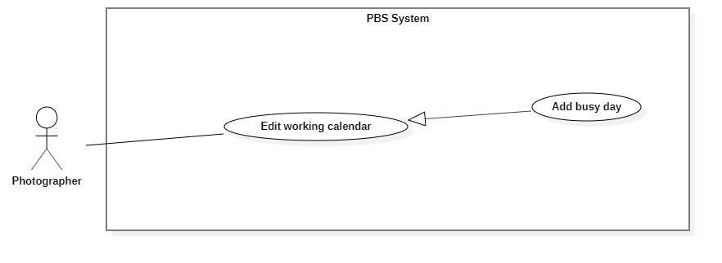

*Figure 22 <Photographer> Add busy day*

|  |  |  |  |  |  |
| --- | --- | --- | --- | --- | --- |
| UC ID and Name: | **UC – 17 Add busy day** | | | | |
| Created By: | Trương Ngọc Mỹ | | Date Created: | 08/10/2020 | |
| Primary Actor: | Photographer | | Secondary Actors: |  | |
| Trigger: | The photographer sends a request to add a busy day. | | | | |
| Description: | This use case allows photographers to add their busy day. | | | | |
| Preconditions: | The User has been authenticated as a Photographer. | | | | |
| Post-conditions: | **Success:** New busy days will be stored in the system.  **Fail:** System outputs error message. | | | | |
| Normal Flow: | **Step** | **Actor Action** | | | **System Response** |
| 1 | Photographer goes on a busy day adding view. | | | System requires information from photographer:   * “Tiêu đề”: text, required * “Mô tả”: text, required * “Ngày nghỉ”: datepicker, required |
| 2 | Photographer inputs required information and sends requests to add busy days. | | | System outputs “Bạn muốn thêm ngày nghỉ?” |
| 3 | Photographer confirm “Có”  [Alternative 1] | | | System add busy day to system and outputs message “Đã thêm ngày nghỉ”  [Exception 1]  [Exception 2] |
| Alternative Flows: | **Step** | **Actor Action** | | | **System Response** |
| 1 | Photographer confirms “Không”. | | | Back to a busy day adding views. |
| Exceptions: | **No** | **Cause** | | | **System Response** |
| 1 | Photographer inputs data incorrectly or leave them empty | | | System outputs error message to notify photographer re-input. |
| 2 | The process runs into an internal error | | | System outputs “Đã có lỗi xảy ra” |
| Priority: | Medium | | | | |
| Frequency of Use: | Sometimes | | | | |
| Business Rules: | * Busy day information contains: busy day note, busy datetime, description on busy day. * If the picked day has booking deal, system will return a message to warn photographer that they have to cancel the booking before set busy day. | | | | |
| Other Information: | N/A | | | | |
| Assumptions: | N/A | | | | |

*Table 20 <Photographer> Add busy day specification*

##### <Photographer> Get customer’s review

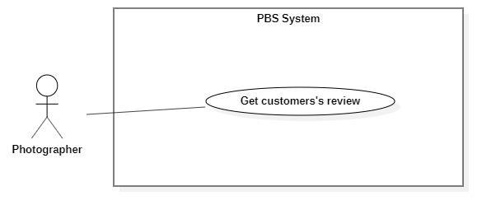

*Figure 23 <Photographer> Get customer's review*

|  |  |  |  |  |  |
| --- | --- | --- | --- | --- | --- |
| UC ID and Name: | **UC – 18 Get customer’s review** | | | | |
| Created By: | Trương Ngọc Mỹ | | Date Created: | 08/10/2020 | |
| Primary Actor: | Photographer, Admin | | Secondary Actors: |  | |
| Trigger: | The photographer or admin sends a request to get a customer's review. | | | | |
| Description: | This use case allows photographers or admins to get customers’ reviews. | | | | |
| Preconditions: | The User has been authenticated as Photographer or Admin | | | | |
| Post-conditions: | **Success:** The system returns customers’ review of photographer  **Fail:** System shows error message | | | | |
| Normal Flow: | **Step** | **Actor Action** | | | **System Response** |
| 1 | Photographer or Admin send requests to get their reviews from customers. | | | System displays list of reviews.  [Exception 1] |
| Alternative Flows: | N/A | | | | |
| Exceptions: | **No** | **Cause** | | | **System Response** |
| 1 | The process runs into an internal error. | | | System outputs error message: “Đã có lỗi xảy ra” |
| Priority: | Medium | | | | |
| Frequency of Use: | Sometimes | | | | |
| Business Rules: | * The results contain: customers’ comments, customers’ ratings, commented dates. * If the result is empty, returns empty text. * Admin can’t delete customers’s reviews | | | | |
| Other Information: | N/A | | | | |
| Assumptions: | N/A | | | | |

*Table 21<Photographer> Get customer's review specification*

##### <Photographer> Add package

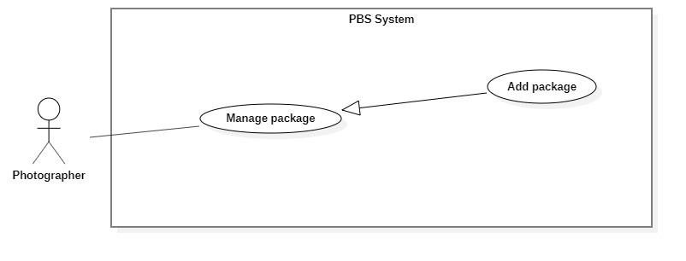

*Figure 24 <Photographer> Add package*

|  |  |  |  |  |  |
| --- | --- | --- | --- | --- | --- |
| UC ID and Name: | **UC – 19 Add package** | | | | |
| Created By: | Đào Sỹ Trung Kiên | | Date Created: | 08/10/2020 | |
| Primary Actor: | Photographer | | Secondary Actors: |  | |
| Trigger: | Photographer sends a request to add a new package. | | | | |
| Description: | This use case allows photographers to add new packages. | | | | |
| Preconditions: | The User has been authenticated as Photographer | | | | |
| Post-conditions: | **Success**: Package will be stored with status active.  **Fail**: System outputs error message and sends to Photographer. | | | | |
| Normal Flow: | **Step** | **Actor Action** | | | **System Response** |
| 1 | Photographer goes to New Package View. | | | System returns “phương thức giao hàng” for execution steps.  System requires information from photographer:  - “Kiểu dịch vụ”: text, required.  - “Tên dịch vụ”: text, required.  - “Mô tả”: text, required.  - “Giá thành dịch vụ”: text, required  - “Thời gian tác nghiệp”: text, required  - “Chi tiết dịch vụ”: text, required.  - “Phương thức giao hàng”: drop list, required. |
| 2 | Photographers input required information and send requests to create new packages. | | | System validates information, adds new package to system, output message “Tạo gói dịch vụ thành công” and send to Photographer  [Exception 1]  [Exception 2] |
| Alternative Flows: | N/A | | | | |
| Exceptions: | **No** | **Actor Action** | | | **System Response** |
| 1 | Photographer inputs invalid format text inputs or leaves empty required fields | | | System outputs error message and sends it to ask the photographer to input correct required fields. |
| 2 | The create process encountered an internal error. | | | System outputs error message and sends to photographer and notify that create new package fails. |
| Priority: | Medium | | | | |
| Frequency of Use: | Sometimes | | | | |
| Business Rules: | * Package will be managed by the system with status active and deactivated. * Package information contains: Id, package category, package name, description, price, time anticipation, services, returning type, isSupportMultiDay. * Package id will be generated by the system. * Returning types and category option list drop returned by system. * IsSupportMultiDay is a boolean. * After creating a new package successfully, the new package will have status active and available for customers to choose. | | | | |
| Other Information: | N/A | | | | |
| Assumptions: | N/A | | | | |

*Table 22 <Photographer> Add package specification*

##### <Photographer> Edit Package

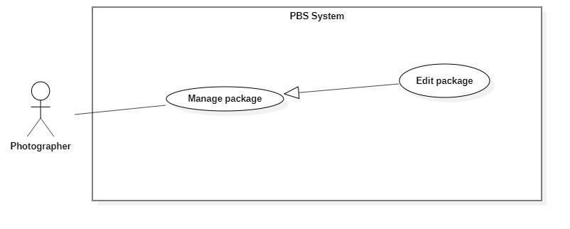

*Figure 25<Photographer> Edit package*

|  |  |  |  |
| --- | --- | --- | --- |
| UC ID and Name: | **UC – 20 Edit package** | | |
| Created By: | Đào Sỹ Trung Kiên | Date Created: | 08/10/2020 |
| Primary Actor: | Photographer | Secondary Actors: |  |
| Trigger: | Photographer sends request to edit package. | | |
| Description: | This use case allows photographers to edit packages. | | |
| Preconditions: | The User has been authenticated as Photographer | | |
| Post-conditions: | **Success**: Package is edited.  **Fail**: System outputs error message and sends to Photographer. | | |
| Normal Flow: | **No** | **Actor Action** | **System Response** |
| 1 | Photographers send requests to receive a list of packages. | System display list of packages.  [Exception 1] |
| 2 | Photographer sends request to receive package details | System returns “phương thức giao hàng” for execution steps.  System requires information from photographer:  - “Kiểu dịch vụ”: text, required.  - “Tên dịch vụ”: text, required.  - “Mô tả”: text, required.  - “Giá thành dịch vụ”: text, required  - “Thời gian tác nghiệp”: text, required  - “Chi tiết dịch vụ”: text, required.  - “Phương thức giao hàng”: drop list, required.  [Exception 2] |
|  | 3 | Photographer inputs package required information and send request to update package | System validates information, updates package, sends output message: “Chỉnh sửa thành công” to photographer.  [Exception 3]  [Exception 4] |
| Alternative Flows: | N/A | | |
| Exceptions: | **No** | **Actor Action** | **System Response** |
| 1 | System retrieves an empty list of available packages. | System outputs the error message “Không tìm thấy package” and sends it to the photographer. |
| 2 | System retrieves an empty list of “Phương thức giao hàng”. | System outputs error message “Không tìm thấy phương thức giao hàng” and sends to photographer. |
| 3 | Photographer inputs invalid format text inputs or leaves empty required fields. | System outputs error message and sends it to photographer to ask photographer to input correct required fields. |
| 4 | Update package process encountered a system internal error. | System outputs error message to notify photographer that update package failed. |
| Priority: | Medium | | |
| Frequency of Use: | Sometimes | | |
| Business Rules: | * Photographers only access packages via package id. * Package will be updated in the system with inputted information. * Package id cannot be updated. * Package will be managed by the system with status active and deactivated. * Package information contains: Id, package category, package name, description, price, time anticipation, services, returning type, isSupportMultiDay. * IsSupportMultiDay is a boolean. * Returning type and category option list returned by system. * After updating the package successfully, the package will have new value and available for customers to choose. | | |
| Other Information: | N/A | | |
| Assumptions: | N/A | | |

*Table 23 <Photographer> Edit package specification*

##### <Photographer> Remove Package

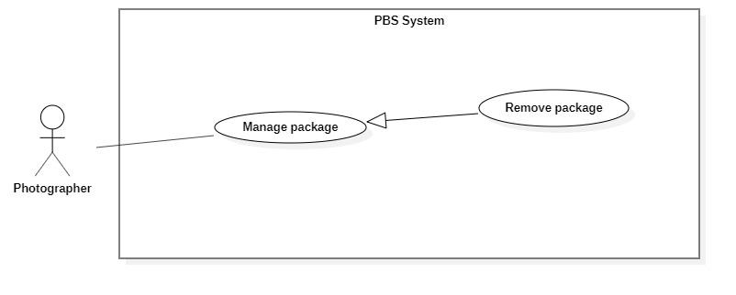

*Figure 26 <Photographer> Remove package*

|  |  |  |  |  |  |
| --- | --- | --- | --- | --- | --- |
| UC ID and Name: | **UC – 21 Remove package** | | | | |
| Created By: | Đào Sỹ Trung Kiên | | Date Created: | 08/10/2020 | |
| Primary Actor: | Photographer | | Secondary Actors: |  | |
| Trigger: | Photographer sends request to delete package. | | | | |
| Description: | This use case allows photographers to delete packages. | | | | |
| Preconditions: | The User has been authenticated as Photographer | | | | |
| Post-conditions: | **Success**: Package is set to deactivated.  **Fail**: System outputs error message and sends to Photographer. | | | | |
| Normal Flow: | **Step** | **Actor Action** | | | **System Response** |
| 1 | Photographer sends a request to get a list package. | | | System returns and displays list package.  [Exception 1] |
| 2 | Photographer sends request to delete package. | | | System outputs confirm messages: “Bạn có muốn xóa gói dịch vụ này không ?” and requires Photographer to confirm. |
| 2 | Photographer confirms “Đồng ý” to delete the package. | | | System outputs and sends message: “Xóa gói dịch vụ thành công” to photographer and updates list package.  [Exception 2] |
| Alternative Flows: | N/A | | | | |
| Exceptions: | **No** | **Actor Action** | | | **System Response** |
| 1 | System retrieves an empty list package. | | | System outputs error message “Không có gói dịch vụ nào” and sends to photographer. |
| 2 | The delete action process encountered an internal error. | | | System outputs error message and sends it to photographer to notify that the delete package failed. |
| Priority: | Medium | | | | |
| Frequency of Use: | Sometimes | | | | |
| Business Rules: | * Photographers only access packages via package id. * If package status is active: Update status to deactivate. * Package which currently has been booking can’t not be removed. | | | | |
| Other Information: | N/A | | | | |
| Assumptions: | N/A | | | | |

*Table 24 <Photographer> Remove package specification*

##### <Photographer> Add album

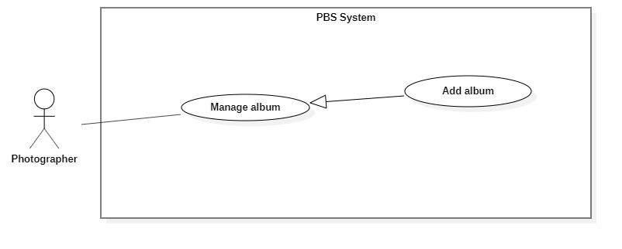

*Figure 27 <Photographer> Add album*

|  |  |  |  |  |  |
| --- | --- | --- | --- | --- | --- |
| UC ID and Name: | **UC – 22 Add album** | | | | |
| Created By: | Đào Sỹ Trung Kiên | | Date Created: | 08/10/2020 | |
| Primary Actor: | Photographer | | Secondary Actors: |  | |
| Trigger: | The photographer sends request to add new album | | | | |
| Description: | This use case allows Photographer to add new album | | | | |
| Preconditions: | The User has been authenticated as Photographer | | | | |
| Post-conditions: | **Success:** Album will be added successfully  **Fail:** Systems outputs error message and sends to Photographer | | | | |
| Normal Flow: | **Step** | **Actor Action** | | | **System Response** |
| 1 | The Photographer goes to new Package View | | | System returns “category” for execution steps.  System requires information from photographer:  - “Ngày tạo”: datetime, required.  - “Mô tả”: text, required.  - “Tên album”: text, required.  - “Hình ảnh”: picture, required.  - “Category”: chips, required  - “Địa điểm”: text, required. |
| 2 | Photographer inputs required information and send request to create new album | | | System validates information, adds new album to the system, outputs message “Tạo mới album thành công” and sends to the Photographer  [Exception 1]  [Exception 2] |
| Alternative Flows: | N/A | | | | |
| Exceptions: | **No** | **Actor Action** | | | **System Response** |
| 1 | Photographer inputs invalid format text inputs or leaves empty require fields. | | | System outputs error message and send to ask Photographer to input correct required fields. |
| 2 | The create process encountered an internal error. | | | System outputs error message and sends photographer to notify that create new album failed. |
| Priority: | Medium | | | | |
| Frequency of Use: | Sometimes | | | | |
| Business Rules: | * Album will be managed by the system with status active and deactivated. * Album information contains: id, created date, description, album’s name, images, category. * Album id will be generated by the system. * Category option list returned by system. * After creating new album successfully, new album will have status active and available for customers. | | | | |
| Other Information: | N/A | | | | |
| Assumptions: | N/A | | | | |

*Table 25 <Photographer> Add album specification*

##### <Photographer> Edit album

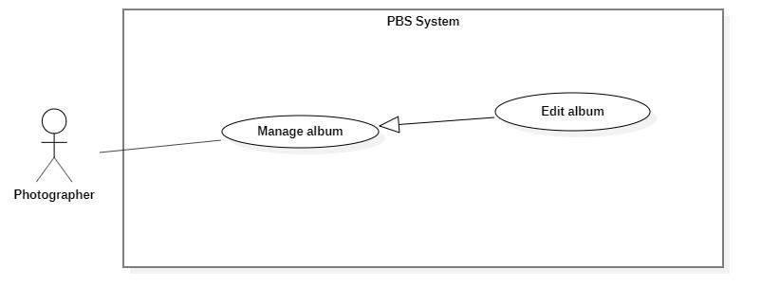

*Figure 28 <Photographer> Edit album*

|  |  |  |  |  |  |
| --- | --- | --- | --- | --- | --- |
| UC ID and Name: | **UC – 23 Edit album** | | | | |
| Created By: | Đào Sỹ Trung Kiên | | Date Created: | 08/10/2020 | |
| Primary Actor: | Photographer | | Secondary Actors: |  | |
| Trigger: | The photographer sends request to edit album | | | | |
| Description: | This use case allows Photographer to edit album | | | | |
| Preconditions: | The User has been authenticated as Photographer | | | | |
| Post-conditions: | **Success:** Album will be updated  **Fail:** Systems outputs error message and sends to Photographer | | | | |
| Normal Flow: | **No** | **Actor Action** | | | **System Response** |
| 1 | Photographers send requests to receive a list of albums. | | | System display list of albums.  [Exception 1] |
| 2 | Photographer sends request to receive album details | | | System returns “category” for execution steps.  System requires information from photographer:  - “Ngày tạo”: datetime, required.  - “Mô tả”: text, required.  - “Tên album”: text, required.  - “Hình ảnh”: picture, required.  - “Category”: chips, required  - “Địa điểm”: text, required.  [Exception 2] |
| 3 | Photographer inputs album required information and send request to update album | | | System validates information, updates package, sends output message: “Chỉnh sửa thành công” to photographer.  [Exception 3]  [Exception 4] |
| Alternative Flows: | N/A | | | | |
| Exceptions: | **No** | **Actor Action** | | | **System Response** |
| 1 | System retrieves an empty list of available albums. | | | System outputs the error message “Không tìm thấy album” and sends it to the photographer. |
| 2 | System retrieves an empty list of “category”. | | | System outputs the error message “Không tìm thấy category” and sends it to the photographer. |
| 3 | Photographer inputs invalid format text inputs or leaves empty required fields. | | | System outputs error message and sends it to photographer to ask photographer to input correct required fields. |
|  | 4 | Update album process encountered a system internal error. | | | System outputs error message to notify photographer that update album failed. |
| Priority: | Medium | | | | |
| Frequency of Use: | Sometimes | | | | |
| Business Rules: | * Photographers only access albums by album id. * Albums will be updated in the system with inputted information. * Album id cannot be updated. * Albums will be managed by the system with status active and deactivated. * Album information contains: id, created date, description, album’s name, images, category. * Category option list returned by system. * After updating the album successfully, the album will have new value and be available for customers. | | | | |
| Other Information: | N/A | | | | |
| Assumptions: | N/A | | | | |

*Table 26 <Photographer> Edit album specification*

##### <Photographer> Remove album

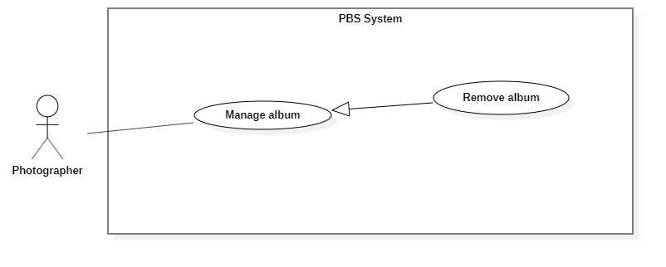

*Figure 29 <Photographer> Remove album*

|  |  |  |  |  |  |
| --- | --- | --- | --- | --- | --- |
| UC ID and Name: | **UC – 24 Remove album** | | | | |
| Created By: | Đào Sỹ Trung Kiên | | Date Created: | 08/10/2020 | |
| Primary Actor: | Photographer | | Secondary Actors: |  | |
| Trigger: | Photographer sends request to delete album | | | | |
| Description: | This use case allows photographers to delete albums. | | | | |
| Preconditions: | The User has been authenticated as Photographer | | | | |
| Post-conditions: | **Success**: Album is set to deactivated.  **Fail**: System outputs error message and sends to Photographer. | | | | |
| Normal Flow: | **Step** | **Actor Action** | | | **System Response** |
| 1 | Photographer sends request to get list album. | | | System returns and displays the list album.  [Exception 1] |
| 2 | Photographer sends request to delete album. | | | System outputs confirm messages: “Bạn có muốn xóa album này không ?” and requires Photographer to confirm. |
| 3 | Photographer confirms “Đồng ý” to delete album. | | | System outputs and sends a message: “Xóa album thành công” to photographer and updates list album.  [Exception 2] |
| Alternative Flows: | N/A | | | | |
| Exceptions: | **No** | **Actor Action** | | | **System Response** |
| 1 | System retrieves an empty list album. | | | System outputs the error message “Không có album nào” and sends it to the photographer. |
| 2 | The delete action process encountered an internal error. | | | System outputs error message and sends it to photographer to notify that the delete album failed. |
| Priority: | Medium | | | | |
| Frequency of Use: | Sometimes | | | | |
| Business Rules: | * Photographers only access albums via album id. * If album status is active: Update status to deactivate. | | | | |
| Other Information: | N/A | | | | |
| Assumptions: | N/A | | | | |

*Table 27<Photographer> Remove album specification*

#### 2.2.4 <Authenticated User> Overview Use Case

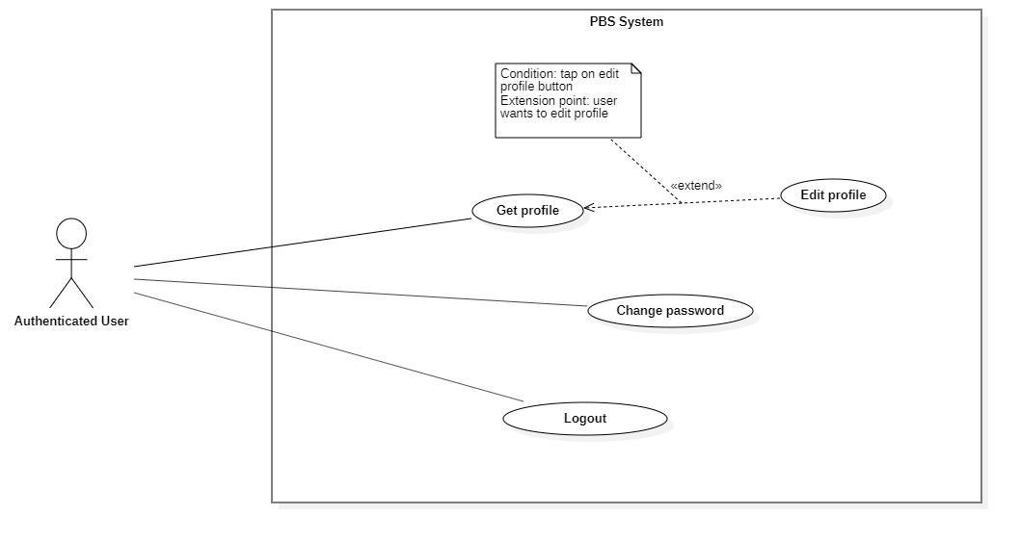

*Figure 30 <Authenticated User> Overview*

##### <Authenticated User> Get profile

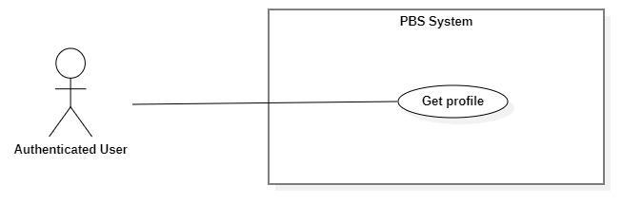

*Figure 31 <Authenticated User> Get profile*

|  |  |  |  |  |  |
| --- | --- | --- | --- | --- | --- |
| UC ID and Name: | **UC – 25 Get profile** | | | | |
| Created By: | Trương Ngọc Mỹ | | Date Created: | 08/10/2020 | |
| Primary Actor: | Authenticated User | | Secondary Actors: |  | |
| Trigger: | The Authenticated User sends request to get profile | | | | |
| Description: | This use case allows authenticated user to get their profile | | | | |
| Preconditions: | User has been authenticated. | | | | |
| Post-conditions: | **Success:** System returns authenticated user’s profile.  **Fail:** System shows error message. | | | | |
| Normal Flow: | **Step** | **Actor Action** | | | **System Response** |
| 1 | Authenticated users send requests to get their profile. | | | System outputs the result to the authenticated user.  [Exception 1]  [Exception 2] |
| Alternative Flows: | N/A | | | | |
| Exceptions: | **No** | **Cause** | | | **System Response** |
| 1 | System can’t get the profile. | | | System outputs error message “Không thể tìm thấy thông tin”. |
| 2 | The process runs into an internal error. | | | System outputs error message “Đã có lỗi xảy ra” |
| Priority: | Medium | | | | |
| Frequency of Use: | Sometimes | | | | |
| Business Rules: | * The results contain following information: user’s avatar, user’ full name, user’s phone, user’s email, user’s description. | | | | |
| Other Information: | N/A | | | | |
| Assumptions: | N/A | | | | |

*Table 28 <Authenticated User> Get profile specification*

##### <Authenticated User> Edit profile

|  |  |  |  |  |  |
| --- | --- | --- | --- | --- | --- |
| UC ID and Name: | **UC – 26 Edit profile** | | | | |
| Created By: | Trương Ngọc Mỹ | | Date Created: | 08/10/2020 | |
| Primary Actor: | Authenticated User | | Secondary Actors: |  | |
| Trigger: | The Authenticated User sends a request to edit the profile. | | | | |
| Description: | This use case allows authenticated users to edit their profile. | | | | |
| Preconditions: | User has been authenticated. | | | | |
| Post-conditions: | **Success:** The profile will be updated into the system.  **Fail:** System outputs error message. | | | | |
| Normal Flow: | **Step** | **Actor Action** | | | **System Response** |
| 1 | Authenticated users send requests to receive their profile. | | | System return results and requires information from user:  - “Họ tên”: text, required  - “Email”: text, required  - “Số điện thoại”: number, required  - “Mô tả”: text  - “Ảnh đại diện”: image  [Exception 1] |
| 2 | Authenticated user input information and send requests to edit their profile. | | | System outputs “Bạn muốn cập nhật hồ sơ?”. |
| 3 | Authenticated confirmation “Có”.  [Alternative 1] | | | System update data and outputs “Đã cập nhật hồ sơ”.  [Exception 2]  [Exception 3] |
| Alternative Flows: | **Step** | **Actor Action** | | | **System Response** |
| 1 | Authenticated confirm “Không”. | | | Back to profile view. |
| Exceptions: | **No** | **Cause** | | | **System Response** |
| 1 | System can’t get user’s profile | | | System outputs “Không thể tìm thấy hồ sơ” |
| 2 | User inputs information incorrectly or leaves it empty in the required field. | | | System outputs error messages to get user input correctly. |
| 3 | System runs into an internal error. | | | System outputs error message “Đã có lỗi xảy ra” |
| Priority: | Medium | | | | |
| Frequency of Use: | Sometimes | | | | |
| Business Rules: | * The return view contains following information: user’s avatar, user’ full name, user’s phone, user’s email, user’s description * User can every information in their profile. | | | | |
| Other Information: | N/A | | | | |
| Assumptions: | N/A | | | | |

*Table 29 <Authenticated User> Edit profile specification*

##### <Authenticated User> Change password

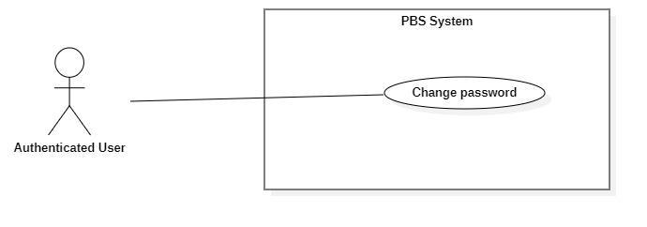

*Figure 33 <Authenticated User> Change password*

|  |  |  |  |  |  |
| --- | --- | --- | --- | --- | --- |
| UC ID and Name: | **UC – 27 Change password** | | | | |
| Created By: | Bồ Công Đạt | | Date Created: | 08/10/2020 | |
| Primary Actor: | Authenticated User | | Secondary Actors: |  | |
| Trigger: | The Authenticated User sends a request to change password. | | | | |
| Description: | This use case allows authenticated users to change their password. | | | | |
| Preconditions: | User has been authenticated. | | | | |
| Post-conditions: | **Success:** User’s password updated successfully in the system.  **Fail:** System outputs error message. | | | | |
| Normal Flow: | **Step** | **Actor Action** | | | **System Response** |
| 1 | Authenticated user sends request to get their password | | | System returns result and requires following information from user:  - “Mật khẩu cũ”: password, required  - “Mật khẩu mới”: password, required  - “Nhập lại mật khẩu”: password, required  [Exception 1] |
| 2 | Authenticated user inputs required information and sends request to change password | | | System outputs “Bạn muốn cập nhật mật khẩu?” |
| 3 | Authenticated user confirms “Có”  [Alternative 1] | | | System update data and output “Cập nhật mật khẩu thành công”  [Exception 2]  [Exception 3] |
| Alternative Flows: | **Step** | **Actor Action** | | | **System Response** |
| 1 | Authenticated user confirms “Không” | | | Back to password changing view |
| Exceptions: | **No** | **Cause** | | | **System Response** |
| 1 | System can’t get user’s password | | | System outputs “Không thể tìm thấy thông tin” |
| 2 | User inputs information incorrectly or leave required fields empty | | | System outputs error message to get user input information correctly |
| 3 | The process runs into an internal error | | | System outputs “Đã có lỗi xảy ra” |
| Priority: | Medium | | | | |
| Frequency of Use: | Sometimes | | | | |
| Business Rules: | * User must input the current password before changing new password. * Password format should be a minimum eight characters, contains at least one number, one letter and one special character. * Save password using SHA256 hash function. | | | | |
| Other Information: | N/A | | | | |
| Assumptions: | N/A | | | | |

*Table 30 <Authenticated User> Change password specification*

##### <Authenticated User> Logout

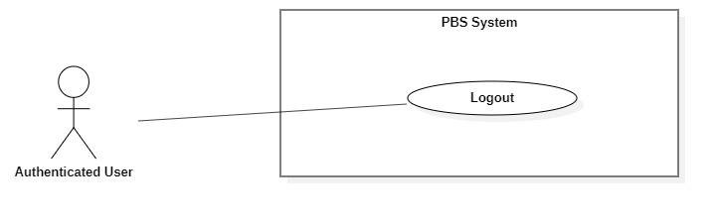

*Figure 34 <Authenticated User> Logout*

|  |  |  |  |  |  |
| --- | --- | --- | --- | --- | --- |
| UC ID and Name: | **UC – 28 Logout** | | | | |
| Created By: | Bồ Công Đạt | | Date Created: | 08/10/2020 | |
| Primary Actor: | Authenticated User | | Secondary Actors: |  | |
| Trigger: | The Authenticated User sends a request to log out from the system. | | | | |
| Description: | This use case allows users to log out from the system. | | | | |
| Preconditions: | User has been authenticated. | | | | |
| Post-conditions: | **Success:** User logged out from the system.  **Fail:** System outputs error message | | | | |
| Normal Flow: | **Step** | **Actor Action** | | | **System Response** |
| 1 | User sends a request to log out from the system. | | | System outputs “Bạn muốn đăng xuất?” |
| 2 | User confirms “Có”  [Alternative 1] | | | System logs the user out.  [Exception 1] |
| Alternative Flows: | **Step** | **Actor Action** | | | **System Response** |
| 1 | User confirms “Không” | | | Back to logout view |
| Exceptions: | **No** | **Cause** | | | **System Response** |
| 1 | The process runs into an internal error | | | System outputs “Đã có lỗi xảy ra” |
| Priority: | Medium | | | | |
| Frequency of Use: | Usually | | | | |
| Business Rules: | * User’s Json web token will be removed on client side. * User’s session will be destroyed on client side. | | | | |
| Other Information: | N/A | | | | |
| Assumptions: | N/A | | | | |

*Table 31 <Authenticated User> Logout specification*

#### 2.2.5 <Admin> Overview Use Case

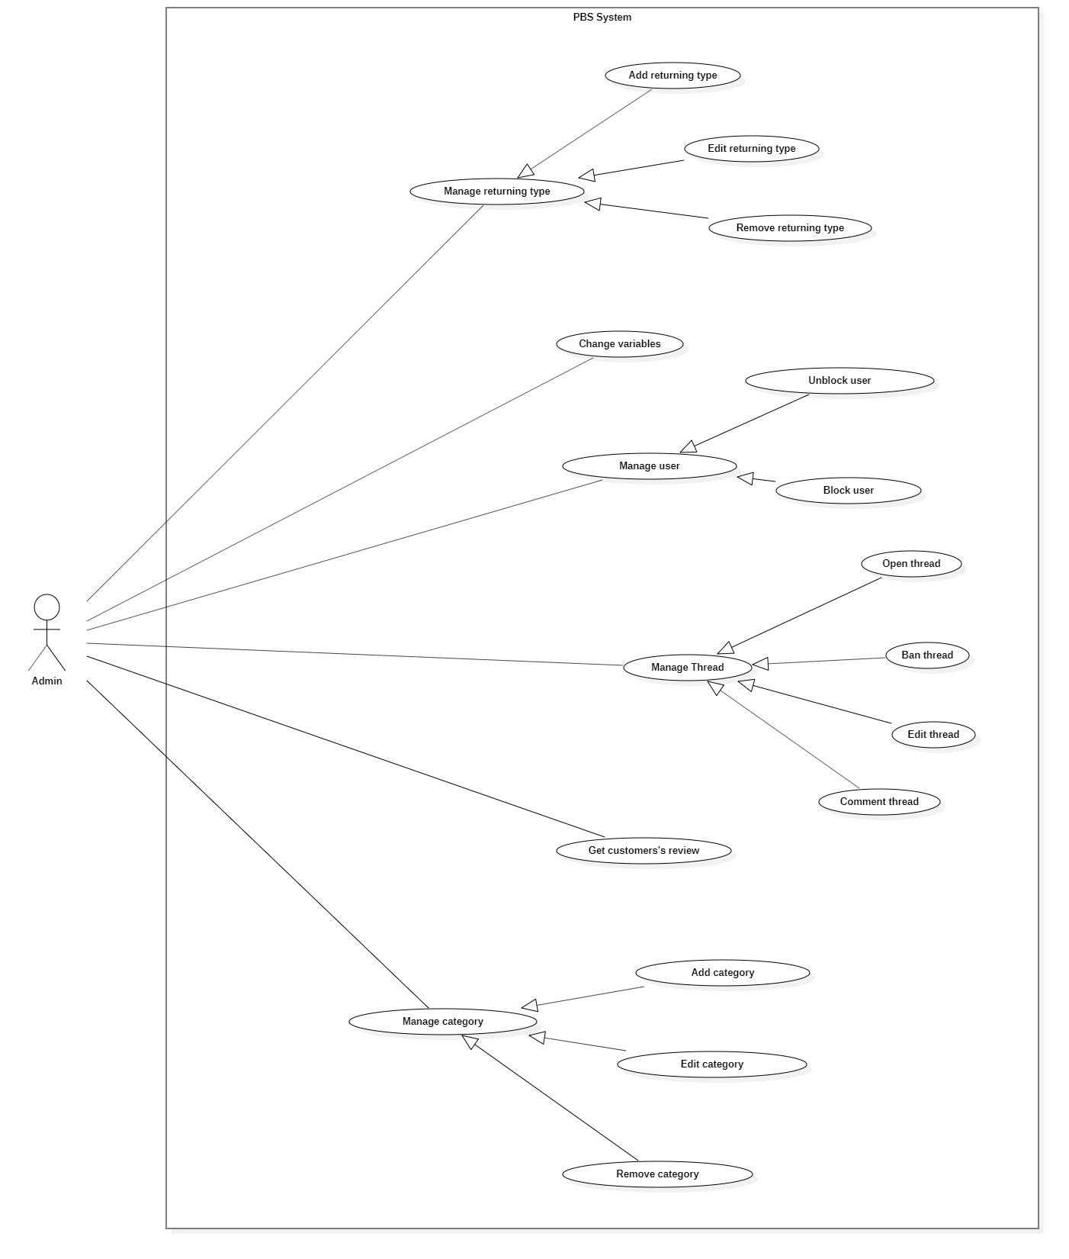

*Figure 35 <Admin> Overview*

##### <Admin> Block user

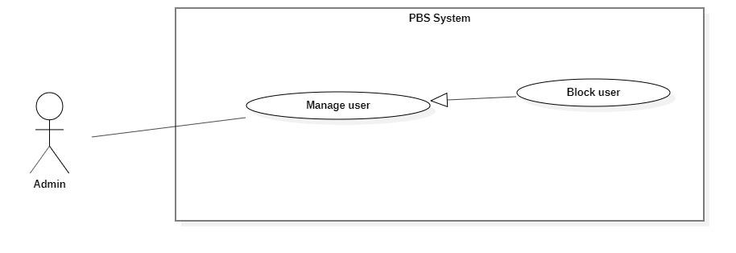

*Figure 36 <Admin> Block user*

|  |  |  |  |  |  |
| --- | --- | --- | --- | --- | --- |
| UC ID and Name: | **UC – 29 Block user** | | | | |
| Created By: | Đào Sỹ Trung Kiên | | Date Created: | 08/10/2020 | |
| Primary Actor: | Admin | | Secondary Actors: |  | |
| Trigger: | The Admin sends request to block user | | | | |
| Description: | This use case allows Admin to block user | | | | |
| Preconditions: | The User has been authenticated as Admin | | | | |
| Post-conditions: | **Success:** User will be blocked and unable to access the system.  **Fail:** Systems outputs error message and sends to Admin | | | | |
| Normal Flow: | **Step** | **Actor Action** | | | **System Response** |
| 1 | The Admin goes to block user view | | | System requires information from admin:  - “User Id”:text, required. |
| 2 | Admin inputs required information and send request to block user | | | System validates information, block user and outputs message “Chặn người dùng thành công” and sends to the admin.  [Exception 1]  [Exception 2] |
| Alternative Flows: | N/A | | | | |
| Exceptions: | **No** | **Actor Action** | | | **System Response** |
| 1 | Admin inputs invalid format text inputs or leaves empty required fields. | | | System outputs error message and sends it to ask admin to input correct required fields. |
| 2 | The create process encountered an internal error. | | | System outputs error message and sends admin to notify that block user failed. |
| Priority: | Medium | | | | |
| Frequency of Use: | Sometimes | | | | |
| Business Rules: | * Users will be managed by the system with status active and deactivated. * Block user if their cancellation above 40%. If their cancellation rate is lower than 40%, warn the admin. * Cancellation rate = number of cancelled bookings / total of bookings. * Save the admin’s name, admin’s id and the datetime of blocking to log file. * Blocked user will have status deactivated. * User information contains: id. * After successfully blocking the user, log the user out if they are logged in. | | | | |
| Other Information: | N/A | | | | |
| Assumptions: | N/A | | | | |

*Table 32 <Admin> Block user specification*

##### <Admin> Unblock user

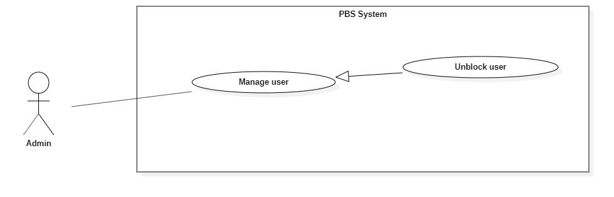

*Figure 37 <Admin> Unblock user*

|  |  |  |  |  |  |
| --- | --- | --- | --- | --- | --- |
| UC ID and Name: | **UC – 30 Unblock user** | | | | |
| Created By: | Đào Sỹ Trung Kiên | | Date Created: | 08/10/2020 | |
| Primary Actor: | Admin | | Secondary Actors: |  | |
| Trigger: | The Admin sends request to unblock album | | | | |
| Description: | This use case allows Admin to unblock user | | | | |
| Preconditions: | The User has been authenticated as Admin | | | | |
| Post-conditions: | **Success:** User will be unblocked and enabled to access the system.  **Fail:** Systems outputs error message and sends to Admin | | | | |
| Normal Flow: | **Step** | **Actor Action** | | | **System Response** |
| 1 | The Admin goes to unblock user view | | | System requires information from admin:  - “User Id”:text, required. |
| 2 | Admin inputs required information and send request to unblock user | | | System validates information, unblock user and outputs message “Gỡ chặn người dùng thành công” and sends to the Admin.  [Exception 1]  [Exception 2] |
| Alternative Flows: | N/A | | | | |
| Exceptions: | **No** | **Actor Action** | | | **System Response** |
| 1 | Admin inputs invalid format text inputs or leaves empty required fields. | | | System outputs error message and sends it to ask admin to input correct required fields. |
| 2 | The create process encountered an internal error. | | | System outputs error message and sends admin to notify that unblock user failed. |
| Priority: | Medium | | | | |
| Frequency of Use: | Sometimes | | | | |
| Business Rules: | * Users will be managed by the system with status active and deactivated. * After unblock user will have status change from deactivated to active. * User information contains: id. * After unblocking the user successfully, this user will be enabled to access the system. | | | | |
| Other Information: | N/A | | | | |
| Assumptions: | N/A | | | | |

*Table 33 <Admin> Unblock user specification*

##### <Admin> Add Category

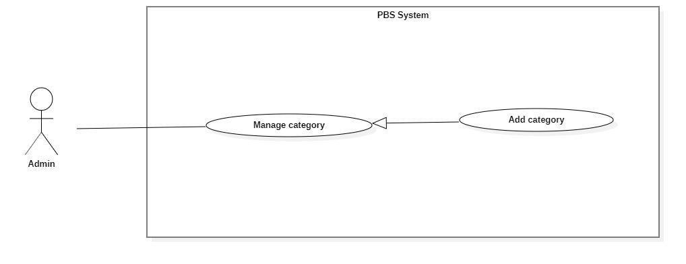

*Figure 38 <Admin> Add category*

|  |  |  |  |  |  |
| --- | --- | --- | --- | --- | --- |
| UC ID and Name: | **UC – 31 Add category** | | | | |
| Created By: | Đào Sỹ Trung Kiên | | Date Created: | 08/10/2020 | |
| Primary Actor: | Admin | | Secondary Actors: |  | |
| Trigger: | The admin sends request to add new category | | | | |
| Description: | This use case allows Admin to add new category | | | | |
| Preconditions: | The User has been authenticated as Admin | | | | |
| Post-conditions: | **Success:** Category will be added successfully  **Fail:** Systems outputs error message and sends to Admin | | | | |
| Normal Flow: | **Step** | **Actor Action** | | | **System Response** |
| 1 | The Admin goes to new Category View | | | System requires information from admin:  - “Tên category”: text, required. |
| 2 | Admin inputs required information and send request to create category | | | System validates information, adds new category to the system, outputs message “Tạo mới category thành công” and sends to the Admin  [Exception 1]  [Exception 2] |
| Alternative Flows: | N/A | | | | |
| Exceptions: | **No** | **Actor Action** | | | **System Response** |
| 1 | Admin inputs invalid format text inputs or leaves empty required fields. | | | System outputs error message and sends it to ask admin to input correct required fields. |
| 2 | The create process encountered an internal error. | | | System outputs error message and sends admin to notify that create new category. |
| Priority: | Medium | | | | |
| Frequency of Use: | Sometimes | | | | |
| Business Rules: | * Category will be managed by the system with status active and deactivated. * Category information contains: id, category name. * Category id will be generated by the system. * After creating a new category successfully, the new category will have status active and available for customer and photographer. | | | | |
| Other Information: | N/A | | | | |
| Assumptions: | N/A | | | | |

*Table 34 <Admin> Add category specification*

##### <Admin> Edit category

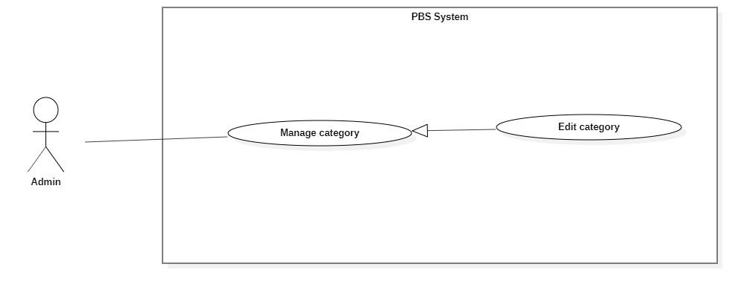

*Figure 39 <Admin> Edit category*

|  |  |  |  |  |  |
| --- | --- | --- | --- | --- | --- |
| UC ID and Name: | **UC – 32 Edit category** | | | | |
| Created By: | Đào Sỹ Trung Kiên | | Date Created: | 08/10/2020 | |
| Primary Actor: | Admin | | Secondary Actors: |  | |
| Trigger: | The admin sends request to edit category | | | | |
| Description: | This use case allows Admin to edit category | | | | |
| Preconditions: | The User has been authenticated as Admin | | | | |
| Post-conditions: | **Success:** Category will be updated  **Fail:** Systems outputs error message and sends to Admin | | | | |
| Normal Flow: | **No** | **Actor Action** | | | **System Response** |
| 1 | Admin sends a request to receive a list of categories. | | | System display list of categories.  [Exception 1] |
| 2 | Admin sends request to receive category details | | | System requires information from admin:  - “Tên category”: text, required. |
| 3 | Admin inputs category required information and send request to update category | | | System validates information, updates category, sends output message: “Chỉnh sửa thành công” to admin.  [Exception 2]  [Exception 3] |
| Alternative Flows: | N/A | | | | |
| Exceptions: | **No** | **Actor Action** | | | **System Response** |
| 1 | System retrieves an empty list of available categories. | | | System outputs the error message “Không tìm thấy category” and sends it to the admin. |
| 2 | Admin inputs invalid format text inputs or leaves empty required fields. | | | System outputs error message and send to ask admin to input correct required fields |
|  | 3 | Update category process encountered a system internal error. | | | System outputs error message to notify admin that update category failed. |
| Priority: | Medium | | | | |
| Frequency of Use: | Sometimes | | | | |
| Business Rules: | * Admin only access category by category id. * Category will be updated in the system with inputted information. * Category id cannot be updated. * Category will be managed by the system with status active and deactivated. * Category information contains: id, category name. * After updating Category successfully, category will have new value and available for customer and photographer. | | | | |
| Other Information: | N/A | | | | |
| Assumptions: | N/A | | | | |

*Table 35 <Admin> Edit category specification*

##### <Admin> Remove category

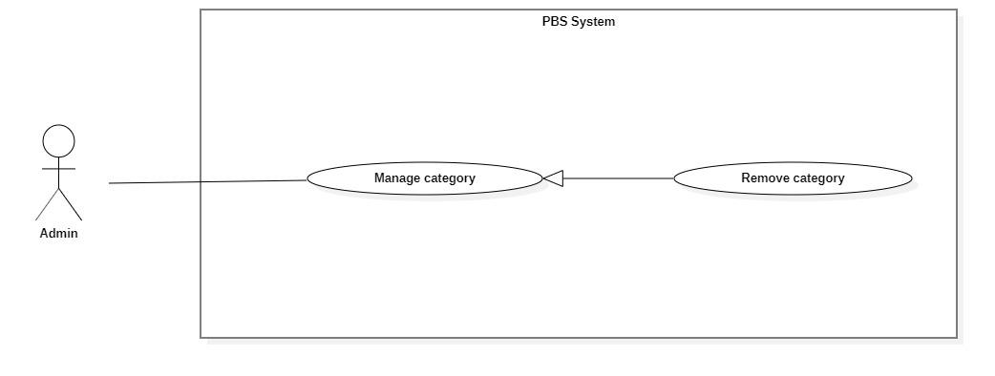

*Figure 40 <Admin> Remove category*

|  |  |  |  |  |  |
| --- | --- | --- | --- | --- | --- |
| UC ID and Name: | **UC – 33 Remove category** | | | | |
| Created By: | Đào Sỹ Trung Kiên | | Date Created: | 08/10/2020 | |
| Primary Actor: | Admin | | Secondary Actors: |  | |
| Trigger: | Admin sends a request to delete the category. | | | | |
| Description: | This use case allows the admin to delete categories. | | | | |
| Preconditions: | The User has been authenticated as Admin | | | | |
| Post-conditions: | **Success**: Category is set to deactivated.  **Fail**: System outputs error message and sends to Admin. | | | | |
| Normal Flow: | **Step** | **Actor Action** | | | **System Response** |
| 1 | Admin sends a request to get a list category. | | | System returns and displays list category.  [Exception 1] |
| 2 | Admin sends a request to delete category. | | | System outputs confirm messages: “Bạn có muốn xóa category này không ?” and requires Admin to confirm. |
| 3 | Admin confirms “Đồng ý” to delete the category. | | | System outputs and sends a message: “Xóa category thành công” to the admin and updates list category.  [Exception 2] |
| Alternative Flows: | N/A | | | | |
| Exceptions: | **No** | **Actor Action** | | | **System Response** |
| 1 | System retrieves an empty list category. | | | System outputs the error message “Không có category nào” and sends it to the admin. |
| 2 | The delete action process encountered an internal error. | | | System outputs error message and sends it to admin to notify that delete category failed. |
| Priority: | Medium | | | | |
| Frequency of Use: | Sometimes | | | | |
| Business Rules: | * Admin only access category by category id. * If category status is active: Update status to deactivate. * Customers and photographers will not use this category. * If other information has dependence on category, Admin cannot remove the category. | | | | |
| Other Information: | N/A | | | | |
| Assumptions: | N/A | | | | |

*Table 36 <Admin> Remove category specification*

##### <Admin> Add returning type

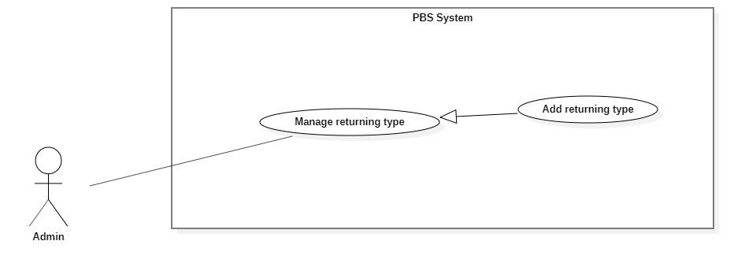

*Figure 41 <Admin> Add returning type*

|  |  |  |  |  |  |
| --- | --- | --- | --- | --- | --- |
| UC ID and Name: | **UC – 34 Add returning type** | | | | |
| Created By: | Đào Sỹ Trung Kiên | | Date Created: | 08/10/2020 | |
| Primary Actor: | Admin | | Secondary Actors: |  | |
| Trigger: | The admin sends request to add new returning type | | | | |
| Description: | This use case allows Admin to add new returning type | | | | |
| Preconditions: | The User has been authenticated as Admin | | | | |
| Post-conditions: | **Success:** Returning type will be added successfully  **Fail:** Systems outputs error message and sends to Admin | | | | |
| Normal Flow: | **Step** | **Actor Action** | | | **System Response** |
| 1 | The Admin goes to new Returning type View | | | System requires information from admin:  - “Tên returning type”: text, required. |
| 2 | Admin inputs required information and send request to create returning type | | | System validates information, adds new returning type to the system, outputs message “Tạo mới returning type thành công” and sends to the Admin  [Exception 1]  [Exception 2] |
| Alternative Flows: | N/A | | | | |
| Exceptions: | **No** | **Actor Action** | | | **System Response** |
| 1 | Admin inputs invalid format text inputs or leaves empty required fields. | | | System outputs error message and sends it to ask admin to input correct required fields. |
| 2 | The create process encountered an internal error. | | | System outputs error message and sends admin to notify that create new returning type. |
| Priority: | Medium | | | | |
| Frequency of Use: | Sometimes | | | | |
| Business Rules: | * Returning type will be managed by the system with status active and deactivated. * Returning type information contains: id, returning type name. * Returning type id will be generated by the system. * After creating a new returning type successfully, the new returning type will have status active and available for customer and photographer. | | | | |
| Other Information: | N/A | | | | |
| Assumptions: | N/A | | | | |

*Table 37 <Admin> Add returning type specification*

##### <Admin> Edit returning type

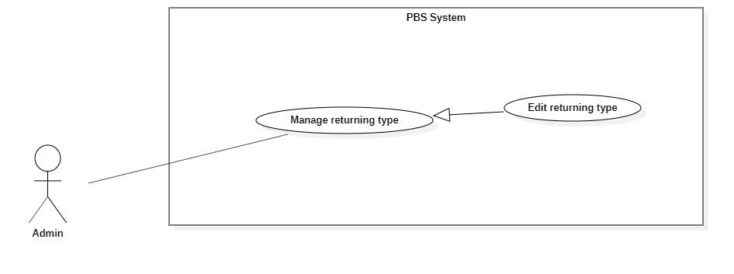

*Figure 42 <Admin> Edit returning type*

|  |  |  |  |  |  |
| --- | --- | --- | --- | --- | --- |
| UC ID and Name: | **UC – 35 Edit returning type** | | | | |
| Created By: | Đào Sỹ Trung Kiên | | Date Created: | 08/10/2020 | |
| Primary Actor: | Admin | | Secondary Actors: |  | |
| Trigger: | The admin sends request to edit returning type | | | | |
| Description: | This use case allows Admin to edit returning type | | | | |
| Preconditions: | The User has been authenticated as Admin | | | | |
| Post-conditions: | **Success:** Returning type will be updated  **Fail:** Systems outputs error message and sends to Admin | | | | |
| Normal Flow: | **No** | **Actor Action** | | | **System Response** |
| 1 | Admin sends a request to receive a list of returning types. | | | System display list of returning type.  [Exception 1] |
| 2 | Admin sends request to receive returning type details | | | System requires information from admin:  - “Tên returning type”: text, required. |
| 3 | Admin inputs returning type required information and send request to update returning type | | | System validates information, updates returning type, sends output message: “Chỉnh sửa thành công” to admin.  [Exception 2]  [Exception 3] |
| Alternative Flows: | N/A | | | | |
| Exceptions: | **No** | **Actor Action** | | | **System Response** |
| 1 | System retrieves an empty list of available returning types. | | | System outputs the error message “Không tìm thấy returning type” and sends it to the admin. |
| 2 | Admin inputs invalid format text inputs or leaves empty required fields. | | | System outputs error message and send to ask admin to input correct required fields |
|  | 3 | Update returning type process encountered a system internal error. | | | System outputs error message to notify admin that update returning type failed. |
| Priority: | Medium | | | | |
| Frequency of Use: | Sometimes | | | | |
| Business Rules: | * Admin only access returning type via returning type id. * Returning type will be updated in the system with inputted information. * Returning type id cannot be updated. * Returning type will be managed by the system with status active and deactivated. * Returning type information contains: id, returning type name. * After updating the returning type successfully, the returning type will have new value and available for customer and photographer. | | | | |
| Other Information: | N/A | | | | |
| Assumptions: | N/A | | | | |

*Table 38 <Admin> Edit returning type specification*

##### <Admin> Remove returning type

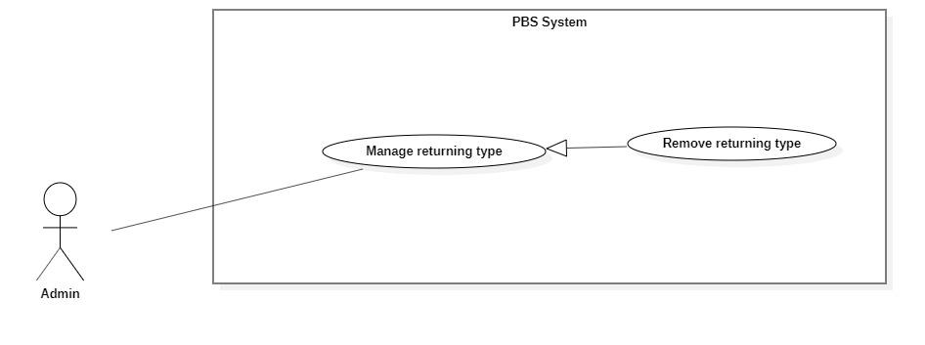

*Figure 43 <Admin> Remove returning type*

|  |  |  |  |  |  |
| --- | --- | --- | --- | --- | --- |
| UC ID and Name: | **UC – 36 Remove returning type** | | | | |
| Created By: | Đào Sỹ Trung Kiên | | Date Created: | 08/10/2020 | |
| Primary Actor: | Admin | | Secondary Actors: |  | |
| Trigger: | Admin sends a request to delete the returning type. | | | | |
| Description: | This use case allows admin to delete returning type. | | | | |
| Preconditions: | The User has been authenticated as Admin | | | | |
| Post-conditions: | **Success**: Returning type is set to deactivated.  **Fail**: System outputs error message and sends to Admin. | | | | |
| Normal Flow: | **Step** | **Actor Action** | | | **System Response** |
| 1 | Admin sends a request to get a list returning type. | | | System returns and displays list returning type.  [Exception 1] |
| 2 | Admin sends request to delete returning type | | | System outputs confirm messages: “Bạn có muốn xóa returning type này không ?” and requires Admin to confirm. |
| 3 | Admin confirms “Đồng ý” to delete the returning type. | | | System outputs and sends a message: “Xóa returning type thành công” to admin and updates list returning type.  [Exception 2] |
| Alternative Flows: | N/A | | | | |
| Exceptions: | **No** | **Actor Action** | | | **System Response** |
| 1 | System retrieves an empty list returning type. | | | System outputs the error message “Không có returning type nào” and sends it to the admin. |
| 2 | The delete action process encountered an internal error. | | | System outputs error message and sends it to admin to notify that delete returning type failed. |
| Priority: | Medium | | | | |
| Frequency of Use: | Sometimes | | | | |
| Business Rules: | * Admin only access returning type via returning type id. * If returning type status is active: Update status to deactivate. * If other information has dependence on returning type, Admin cannot remove the returning type. * Customer and photographer will not use this returning type. | | | | |
| Other Information: | N/A | | | | |
| Assumptions: | N/A | | | | |

*Table 39 <Admin> Remove returning type specification*

##### <Admin> Change variables

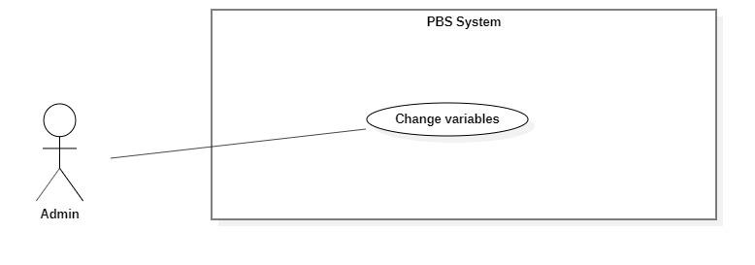

*Figure 44 <Admin> Change variables*

|  |  |  |  |  |  |
| --- | --- | --- | --- | --- | --- |
| UC ID and Name: | **UC – 37 Change variables** | | | | |
| Created By: | Đào Sỹ Trung Kiên | | Date Created: | 08/10/2020 | |
| Primary Actor: | Admin | | Secondary Actors: |  | |
| Trigger: | The admin sends request to change variables | | | | |
| Description: | This use case allows Admin to change variables | | | | |
| Preconditions: | The User has been authenticated as Admin | | | | |
| Post-conditions: | **Success:** Variables will be updated  **Fail:** Systems outputs error message and sends to Admin | | | | |
| Normal Flow: | **No** | **Actor Action** | | | **System Response** |
| 1 | Admin sends request to receive variables details | | | System requires information from admin:  - “Khoảng cách”: number, required.  - “Trung bình giá dịch vụ”: number, required.  - “Đánh giá từ người dùng”: number, required.  [Exception 1] |
| 2 | Admin inputs variables required information and send request to change variables | | | System validates information, change variables, sends output message: “Chỉnh sửa thành công” to admin.  [Exception 2]  [Exception 3] |
| Alternative Flows: | N/A | | | | |
| Exceptions: | **No** | **Actor Action** | | | **System Response** |
| 1 | System retrieves an empty variable. | | | System outputs error message “Không tìm thấy trọng số nào” and sends to admin. |
| 2 | Admin inputs invalid format text inputs or leaves empty required fields. | | | System outputs error message and send to ask admin to input correct required fields |
|  | 3 | Change variables process encountered a system internal error. | | | System outputs error message to notify admin that change variables failed. |
| Priority: | Medium | | | | |
| Frequency of Use: | Sometimes | | | | |
| Business Rules: | * Variables will be updated in the system with inputted information. * Variables id cannot be updated. * Variables information contains: id, variable name. * After changing the variables successfully, variables will have new value. * The sum of the variable is equal to 1 | | | | |
| Other Information: | N/A | | | | |
| Assumptions: | N/A | | | | |

*Table 40 <Admin> Change variables specification*

##### <Admin> Ban thread

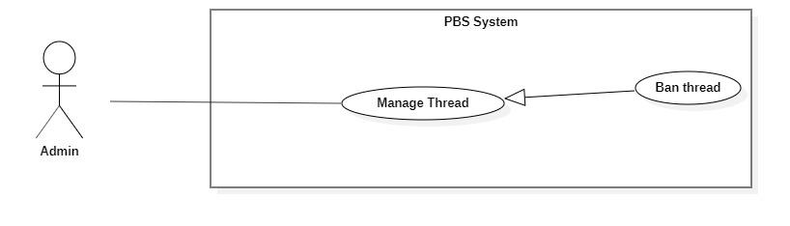

*Figure 45<Admin> Ban thread*

|  |  |  |  |  |  |
| --- | --- | --- | --- | --- | --- |
| UC ID and Name: | **UC – 38 Ban thread** | | | | |
| Created By: | Bồ Công Đạt | | Date Created: | 08/10/2020 | |
| Primary Actor: | Admin | | Secondary Actors: |  | |
| Trigger: | The Admin sends request to ban thread | | | | |
| Description: | This use case allows Admin to ban thread | | | | |
| Preconditions: | The User has been authenticated as Admin | | | | |
| Post-conditions: | **Success:** Thread will be banned successfully.  **Fail:** Systems outputs error message and sends to Admin | | | | |
| Normal Flow: | **Step** | **Actor Action** | | | **System Response** |
| 1 | The Admin goes to ban thread view. | | | System requires information from admin:  - “Thread id”: text, required. |
| 2 | Admin inputs required information and send request to ban thread | | | System validates information, ban thread and outputs message “Chặn bài đăng thành công” and sends to the admin.  [Exception 1]  [Exception 2] |
| Alternative Flows: | N/A | | | | |
| Exceptions: | **No** | **Actor Action** | | | **System Response** |
| 1 | Admin inputs invalid format text inputs or leaves empty required fields. | | | System outputs error message and sends it to ask admin to input correct required fields. |
| 2 | The create process encountered an internal error. | | | System outputs error message and sends admin to notify that ban thread failed. |
| Priority: | Medium | | | | |
| Frequency of Use: | Sometimes | | | | |
| Business Rules: | * Thread will be managed by the system with status active and banned. * After banning thread, thread’s status will be changed to banned. * Thread information contains: id. * After successfully banning the thread, save the admin name and time who have banned the thread to log file. | | | | |
| Other Information: | N/A | | | | |
| Assumptions: | N/A | | | | |

*Table 41 <Admin> Ban thread specification*

#### 2.2.6 <<system>>Handler Overview use case

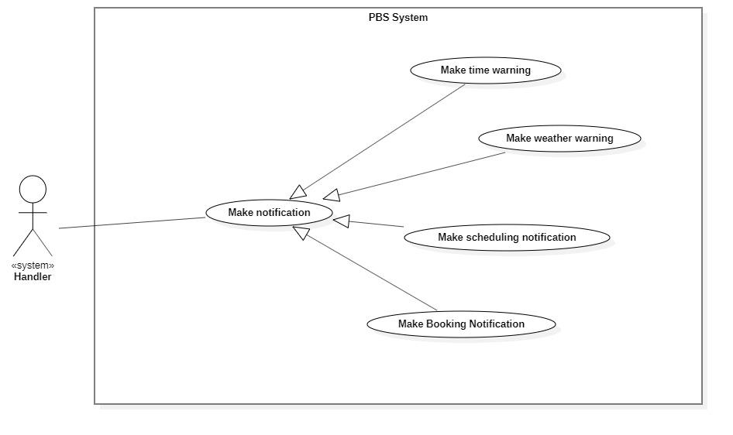

*Figure 46 <System Handler> Overview*

##### <<system>>Handler Make booking notification

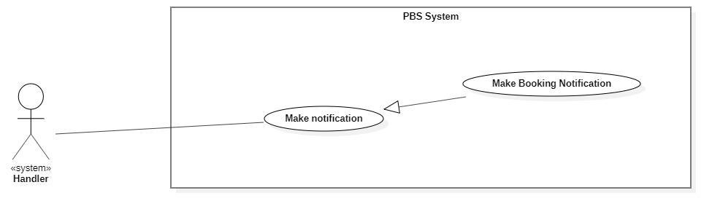

*Figure 47 <System Handler> Make booking notification*

|  |  |  |  |  |  |
| --- | --- | --- | --- | --- | --- |
| UC ID and Name: | **UC – 39 Make booking notification** | | | | |
| Created By: | Bồ Công Đạt | | Date Created: | 08/10/2020 | |
| Primary Actor: | System Handler | | Secondary Actors: |  | |
| Trigger: | System handler sends request to notify photographer or customer whenever booking status is changed | | | | |
| Description: | This use case allows system handler to make booking notification | | | | |
| Preconditions: | N/A | | | | |
| Post-conditions: | **Success:** System make booking notification and sends to photographer or customer  **Fail:** System outputs error and sends to photographer or customer | | | | |
| Normal Flow: | **Step** | **Actor Action** | | | **System Response** |
| 1 | System handler retrieves booking request | | | System stores booking information and return notification to system handler |
| 2 | System handler retrieves notification information and sends to photographer or customer  [Exception 1] | | |  |
| Alternative Flows: | N/A | | | | |
| Exceptions: | **No** | **Cause** | | | **System Response** |
| 1 | The process runs into an internal error | | | System outputs error and sends to photographer or customer |
| Priority: | Medium | | | | |
| Frequency of Use: | Usually | | | | |
| Business Rules: | This use case will be triggered in following situations:   * When customer makes a new booking request. Notification will be sent to photographer. * When photographer accepts an incoming request. Notification will be sent to customer. * When photographer rejects an incoming request. Notification will be sent to customer. * When customer cancels a booking. Notification will be sent to photographer. * When photographer cancels a booking. Notification will be sent to customer. * When photographer changes status of a booking from “Ongoing” to “Editing”. Notification will be sent to customer. * When photographer changes status of a booking from “Editing” to “Done”. Notification will be sent to customer. | | | | |
| Other Information: | N/A | | | | |
| Assumptions: | N/A | | | | |

*Table 42 <System Handler> Make booking notification specification*

##### <<system>>Handler Make scheduling notification

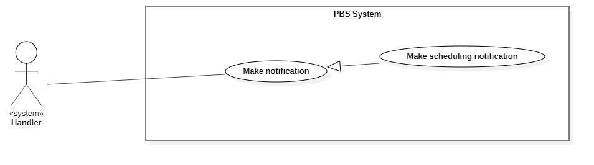

*Figure 48 <System Handler> Make scheduling notification*

|  |  |  |  |  |  |
| --- | --- | --- | --- | --- | --- |
| UC ID and Name: | **UC – 40 Make scheduling notification** | | | | |
| Created By: | Bồ Công Đạt | | Date Created: | 08/10/2020 | |
| Primary Actor: | System Handler | | Secondary Actors: |  | |
| Trigger: | System handler sends a request to notify photographer or customer on scheduling. | | | | |
| Description: | This use case allows system handler to make scheduling notification | | | | |
| Preconditions: | N/A | | | | |
| Post-conditions: | **Success:** System make scheduling notification and sends to photographer or customer  **Fail:** System outputs error and sends to photographer or customer | | | | |
| Normal Flow: | **Step** | **Actor Action** | | | **System Response** |
| 1 | System handler retrieves scheduling changing request | | | System stores scheduling information and return notification to system handler |
| 2 | System handler retrieves notification information and sends to photographer or customer  [Exception 1] | | |  |
| Alternative Flows: |  | | | | |
| Exceptions: | **No** | **Cause** | | | **System Response** |
| 1 | The process runs into an internal error | | | System outputs error and sends to photographer or customer |
| Priority: | Medium | | | | |
| Frequency of Use: | Usually | | | | |
| Business Rules: | This use case will be triggered in following situations:   * When booking start time is current date. Notification will be sent to photographer and customer to notice them about on day booking. | | | | |
| Other Information: | N/A | | | | |
| Assumptions: | N/A | | | | |

*Table 43 <System Handler> Make scheduling notification specification*

##### <<system>>Handler Make weather warning

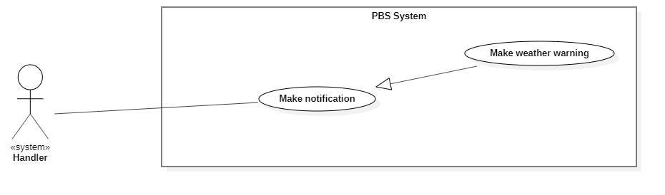

*Figure 49 <System Handler> Make weather warning*

|  |  |  |  |  |  |
| --- | --- | --- | --- | --- | --- |
| UC ID and Name: | **UC – 41 Make weather warning** | | | | |
| Created By: | Bồ Công Đạt | | Date Created: | 08/10/2020 | |
| Primary Actor: | System Handler | | Secondary Actors: |  | |
| Trigger: | System handler sends requests to notify customers of bad weather. | | | | |
| Description: | This use case allows the system handler to make weather warnings. | | | | |
| Preconditions: | N/A | | | | |
| Post-conditions: | **Success:** System makes weather warning and sends to customer.  **Fail:** System outputs error and sends to photographer or customer | | | | |
| Normal Flow: | **Step** | **Actor Action** | | | **System Response** |
| 1 | System handler retrieves bad weather request | | | System stores bad weather information and return notification to system handler |
| 2 | System handler retrieves notification information and sends to photographer or customer  [Exception 1] | | |  |
| Alternative Flows: | N/A | | | | |
| Exceptions: | **No** | **Cause** | | | **System Response** |
| 1 | The process runs into an internal error | | | System outputs error and sends to photographer or customer |
| Priority: | Medium | | | | |
| Frequency of Use: | Usually | | | | |
| Business Rules: | This use case will be triggered in following situations:   * Customer make a new booking, system checks whether if that day’s weather is suitable for shooting and send the warning notification back to her/his based on Naive Bayes Classifiers. | | | | |
| Other Information: | N/A | | | | |
| Assumptions: | N/A | | | | |

*Table 44 <System Handler> Make weather warning specification*

##### <<system>>Handler Make time warning

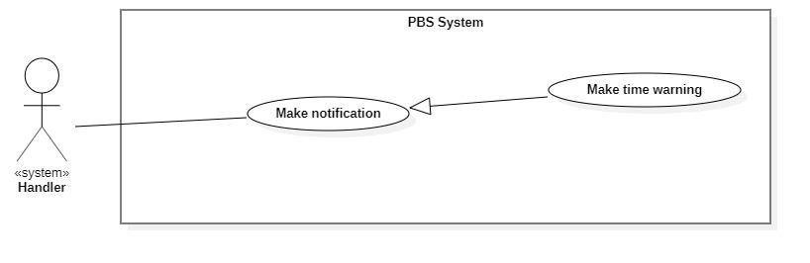

*Figure 50 <System Handler> Make time warning*

|  |  |  |  |  |  |
| --- | --- | --- | --- | --- | --- |
| UC ID and Name: | **UC – 42 Make time warning** | | | | |
| Created By: | Bồ Công Đạt | | Date Created: | 08/10/2020 | |
| Primary Actor: | System Handler | | Secondary Actors: |  | |
| Trigger: | System handler sends requests to notify customers of bad time selection. | | | | |
| Description: | This use case allows the system handler to make time warnings. | | | | |
| Preconditions: | N/A | | | | |
| Post-conditions: | **Success:** System makes time warning and sends to customer.  **Fail:** System outputs error and sends to customer | | | | |
| Normal Flow: | **Step** | **Actor Action** | | | **System Response** |
| 1 | System handler retrieves bad time selection request | | | System stores bad time information and return notification to system handler |
| 2 | System handler retrieves notification information and sends to customer  [Exception 1] | | |  |
| Alternative Flows: | N/A | | | | |
| Exceptions: | **No** | **Cause** | | | **System Response** |
| 1 | The process runs into an internal error | | | System outputs error and sends to customer |
| Priority: | Medium | | | | |
| Frequency of Use: | Usually | | | | |
| Business Rules: | This use case will be triggered in following situations:   * Customer make a new booking, system checks whether if the selected time is too tight for photographer. * For example, photographer have a booking between 9am – 12pm 10/10/2020, if customer book at 13pm 10/10/2020, the system will suggest the customer that photographer may not be able to accept this. | | | | |
| Other Information: | N/A | | | | |
| Assumptions: | N/A | | | | |

*Table 45<System Handler> Make time warning specification*

## 3. Functional Requirements

### 3.1 System Functional Overview

#### a. Screen Flow

1. **Customer’s screen flow**

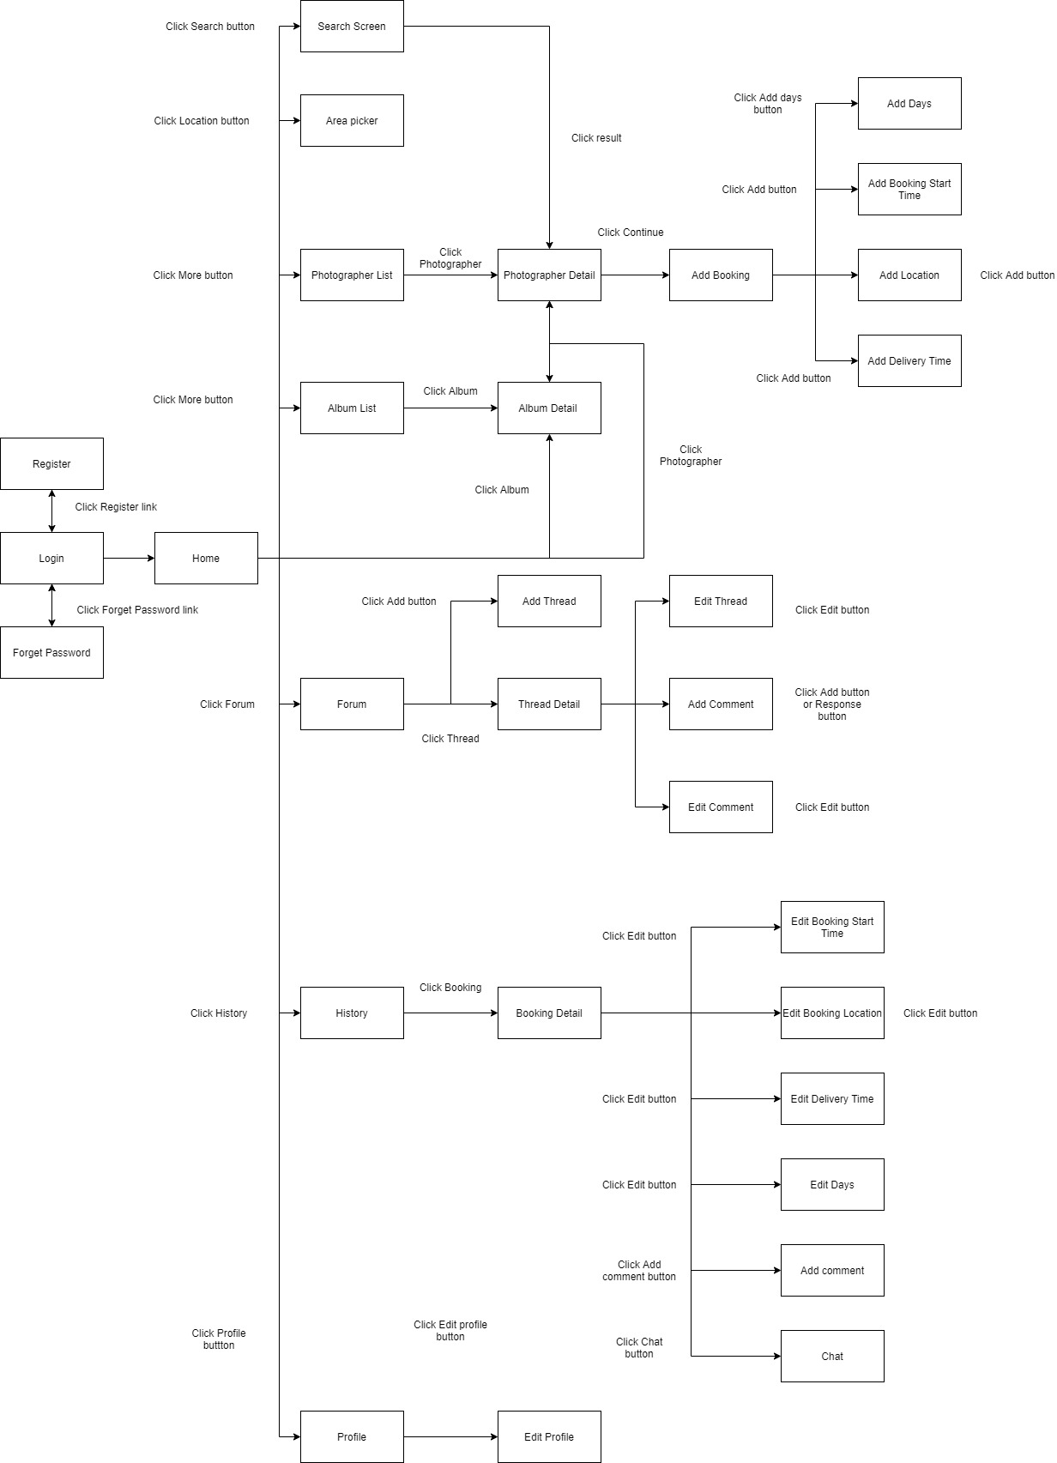

*Figure 51 Customer's screen flow*

1. **Photographer’s screen flow**

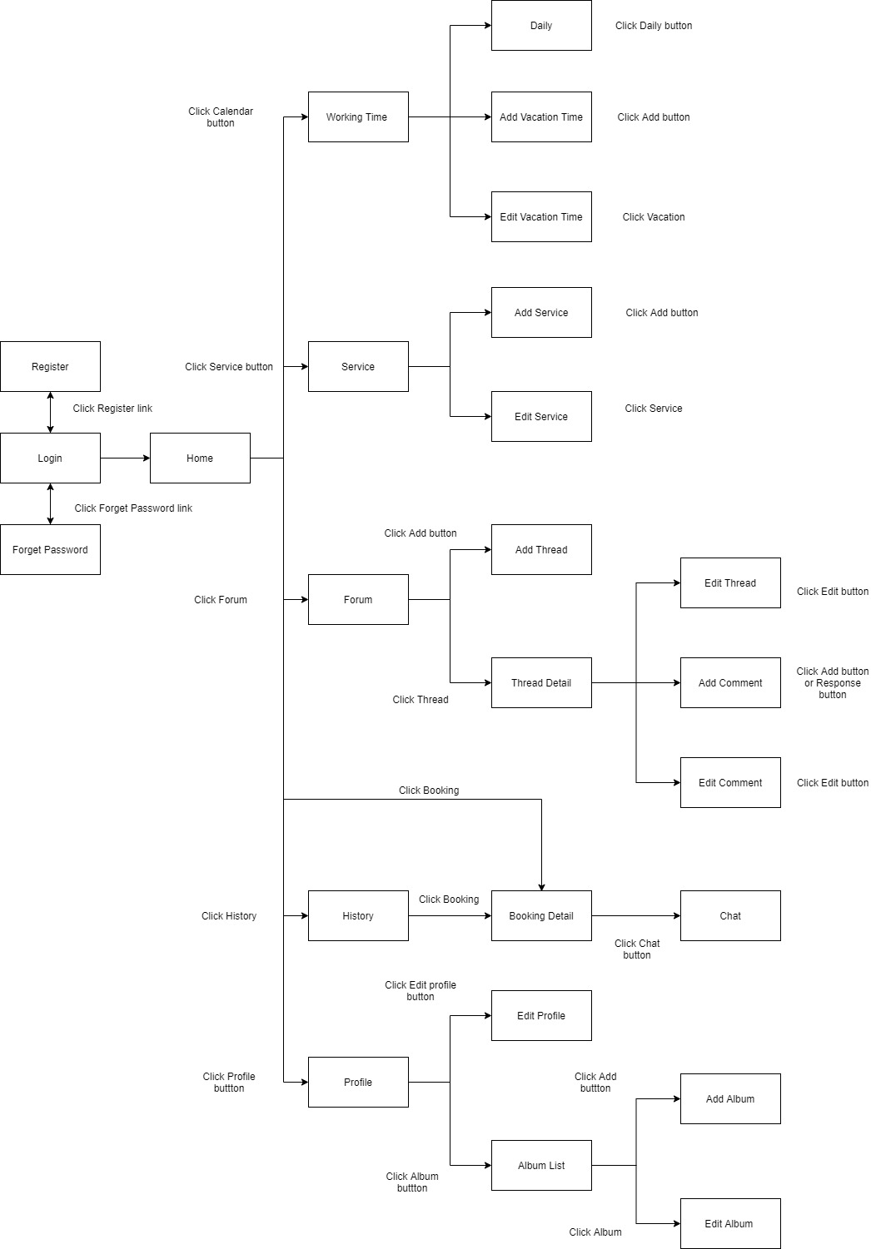

*Figure 52 Photographer's screen flow*

#### b. Screen Details

1. ***Customer’s screen details***

|  |  |  |  |
| --- | --- | --- | --- |
| **#** | **Feature** | **Screen** | **Description** |
| 1 | Register | Register | Register screen included: username textfield, password textfield, re-password textfield |
| 2 | Login | Login | Login screen included: username textfield, password textfield |
| 3 | Forgot password | Forgot password | Forgot password screen included: email textfield |
| 4 | View application | Home | Main screen included: Search icon, category list, photographer list, album list |
| 5 | View profile | Profile | Profile screen included: fullname, username, phone number, email. |
| 6 | Update profile | Edit profile | Edit profile screen included: fullname textfield, phone number textfield, email textfield. |
| 7 | View photographer | Photographer List | Photographer list screen included: photographer name, price, working location, rate. |
| Photographer Detail | Detail request screen included: photographer name, describe, album, review, schedule, package. |
| 9 | Booking | Add Booking | Add booking screen included: photographer name, start time button, delivery time button, location button, package drop list, delivery method drop list. |
| Add Days | Add days screen included: photographer name, days button, delivery time button, location button, package drop list, delivery method drop list. |
| Add Booking Start Time | Add booking start time screen included: calendar picker, time picker. |
| Add Location | Add location include: map picker |
| Add Delivery Time | Add delivery time screen included: calendar picker, time picker. |
| 14 | View album | Album List | Album list screen included: name, rating. |
| Album Detail | Album detail screens include: name, rating, describe, date, location. |
| 16 | View forum | Forum | Forum screen included: list thread |
| 17 | Add thread | Add Thread | Add thread screen included: name textfield , topic button, detail textfield |
| 18 | View thread | Thread Detail | Thread detail screen included: thread, comment |
| 19 | Edit thread | Edit Thread | Edit thread screen included: name textfield, detail textfield |
| 20 | Add comment in forum | Add Comment | Add comment screen included: comment textfield |
| 21 | Edit comment in forum | Edit Comment | Edit comment screen included: comment textfield |
| 22 | View booking | History | History screen included: booking list |
| Booking Detail | Booking detail screen included: photographer name, chat, location, start time, delivery time, delivery method, package |
| 24 | Edit booking | Edit Booking Start Time | Edit booking start time screen included: time picker, calendar picker |
| Edit Booking Location | Edit booking location screen included: map picker |
| Edit Delivery Time | Edit delivery screen included: time picker, calendar picker |
| Edit Days | Edit days screen included: days button |
| 27 | Add comment | Add Comment | Add comment screen included: rating slider, comment textfield |
| 28 | Chat | Chat | Chat screen included: chat bubble, chat textfield |
| 29 | Pick shooting area | Area Picker | Area picker screen included: map picker |
| 30 | Search photographer and package | Search | Search screen included: search area, result area |

*Table 46 Customer's screen details*

1. ***Photographer’s screen details***

|  |  |  |  |
| --- | --- | --- | --- |
| **#** | **Feature** | **Screen** | **Description** |
| 1 | Register | Register | Register screen included: username textfield, password textfield, re-password textfield |
| 2 | Login | Login | Login screen included: username textfield, password textfield |
| 3 | Forgot password | Forgot password | Forgot password screen included: email textfield |
| 4 | View application | Home | Main screen included: calendar icon, pending task list, to do task list |
| 5 | View profile | Profile | Profile screen included: fullname, username, phone number, working location, email. |
| 6 | Update profile | Edit profile | Edit profile screen included: fullname textfield, phone number textfield, working location picker, email textfield. |
| 7 | View album | Album List | Album list screen included: album picture |
| 8 | Add album | Add Album | Add album screen included: album name textfield, date picker, location picker, describe textfield, category picker, photo picker |
| 9 | Edit album | Edit Album | Edit album screen included: album name textfield, date picker, location picker, describe textfield, category picker, photo picker |
| 10 | View forum | Forum | Forum screen included: list thread |
| 11 | Add thread | Add Thread | Add thread screen included: name textfield, topic button, detail textfield |
| 12 | View thread | Thread Detail | Thread detail screen included: thread, comment |
| 13 | Edit thread | Edit Thread | Edit thread screen included: name textfield, detail textfield |
| 14 | Add comment in forum | Add Comment | Add comment screen included: comment textfield |
| 15 | Edit comment in forum | Edit Comment | Edit comment screen included: comment textfield |
| 16 | Booking | History | History screen included: booking list |
| Booking Detail | Booking detail screen included: customer name, chat, location, start time, delivery time, delivery method, package |
| 17 | Chat | Chat | Chat screen included: chat bubble, chat textfield |
| 18 | View working time | Working time | Working time screen included: daily button, add vacation button, vacation day list |
| 19 | Manage daily working time | Daily | Daily screen included: day of the week picker, begin time picker, end time picker |
| 20 | Add vacation time | Add Vacation time | Add vacation time included: calendar picker, name textfield |
| 21 | Edit vacation time | Edit Vacation time | Edit vacation time included: calendar picker, name textfield |
| 22 | View Service | Service | Service screen included: service list |
| 23 | Add Service | Add Service | Add service included: service type radio button, service name textfield, category drop list, describe textfield, duration textfield, price textfield, delivery type picker, detail list |
| 24 | Edit Service | Edit Service | Edit service included: service type radio button, service name textfield, category drop list, describe textfield, duration textfield, price textfield, delivery type picker, detail list |

*Table 47 Photographer's screen details*

#### c. Screen Authorization

|  |  |  |  |  |  |
| --- | --- | --- | --- | --- | --- |
| **Screen** | **Guest** | **Customer** | **Photographer** | **Admin** | **Authenticated User** |
| Register | X |  |  |  |  |
| Login |  | X | X | X | X |
| Forgot password |  | X | X | X | X |
| Home |  | X | X | X |  |
| Profile |  | X | X | X | X |
| Edit profile |  | X | X | X | X |
| Photographer List |  | X |  |  |  |
| Photographer Detail |  | X |  |  |  |
| Add Booking |  | X |  |  |  |
| Add Days |  | X |  |  |  |
| Add Booking Start Time |  | X |  |  |  |
| Add Location |  | X |  |  |  |
| Add Delivery Time |  | X |  |  |  |
| Album List |  | X | X |  |  |
| Album Detail |  | X | X |  |  |
| Add Album |  |  | X |  |  |
| Edit Album |  |  | X |  |  |
| Forum |  | X | X | X |  |
| Add Thread |  | X | X | X |  |
| Thread Detail |  | X | X | X |  |
| Edit Thread |  | X | X | X |  |
| Add Comment in Forum |  | X | X | X |  |
| Edit Comment in Forum |  | X | X | X |  |
| History |  | X | X |  |  |
| Booking Detail |  | X | X |  |  |
| Edit Booking Start Time |  | X |  |  |  |
| Edit Booking Location |  | X |  |  |  |
| Edit Delivery Time |  | X |  |  |  |
| Edit Days |  | X |  |  |  |
| Add Comment |  | X |  |  |  |
| Chat |  | X | X |  |  |
| Area Picker |  | X |  |  |  |
| Working time |  |  | X |  |  |
| Daily |  |  | X |  |  |
| Add Vacation time |  |  | X |  |  |
| Edit Vacation time |  |  | X |  |  |
| Service |  |  | X |  |  |
| Add Service |  |  | X |  |  |
| Edit Service |  |  | X |  |  |

*Figure 53 Screen authorization*

In which:

* Guest: The user has not registered for an account.
* Customer: The user who used this app for booking photographer services.
* Photographer: The user who used this app for providing services.
* Admin: The user who manages the whole system.
* Authenticated user: The user who has logged in to the system successfully.

#### d. Non-Screen Functions

|  |  |  |  |
| --- | --- | --- | --- |
| **No** | **Feature** | **System Function** | **Description** |
| 1 | Authentication | Register | Function allows user to register into the system to be either photographer or customer. |
| Login | Function allows user to log into the system if they have account. |
| 2 | Booking | Book photographer | Function allows customer to book a photographer. |
| Accept booking | Function allows photographer to accept incoming request. |
| Reject booking | Function allows photographer to reject incoming request. |
| Cancel booking | Function allows photographer or customer to cancel booking. But if their cancel is inappropriate, they could be ban by admin. |
| Edit booking | Function allows customer to edit their request, they can edit information like time, location or package. |
| Review booking | Function allows customer to review booking after it done. |
| 3 | Photographer | Manage package | Function allows photographer to manage their package service. |
| Manage album | Function allows photographer to manage their album. |
| Manage working calendar | Function allows photographer to manage their working schedule including add busy day, edit working weekday. |
| 4 | Forum | Open thread | Function allows user to open new thread. |
| Edit thread | Function allows user to edit their posted thread. |
| Comment thread | Function allows user to comment on a thread. |
| Ban thread | Function allows admin to ban a thread. |
| 5 | Profile | Edit profile | Function allows user to change their basic information like full name, avatar, etc. |
| Change password | Function allows user to change their password. |
| 6 | Notification | Make weather warning | Function allows system to warn customer about bad weather. |
| Make scheduling notification | Function allows system to notify customer or photographer on their schedule. |
| Make booking notification | Function allows system to notify customer or photographer about booking. |

*Table 48 Non-screen functions*

#### e. Entity Relationship Diagram

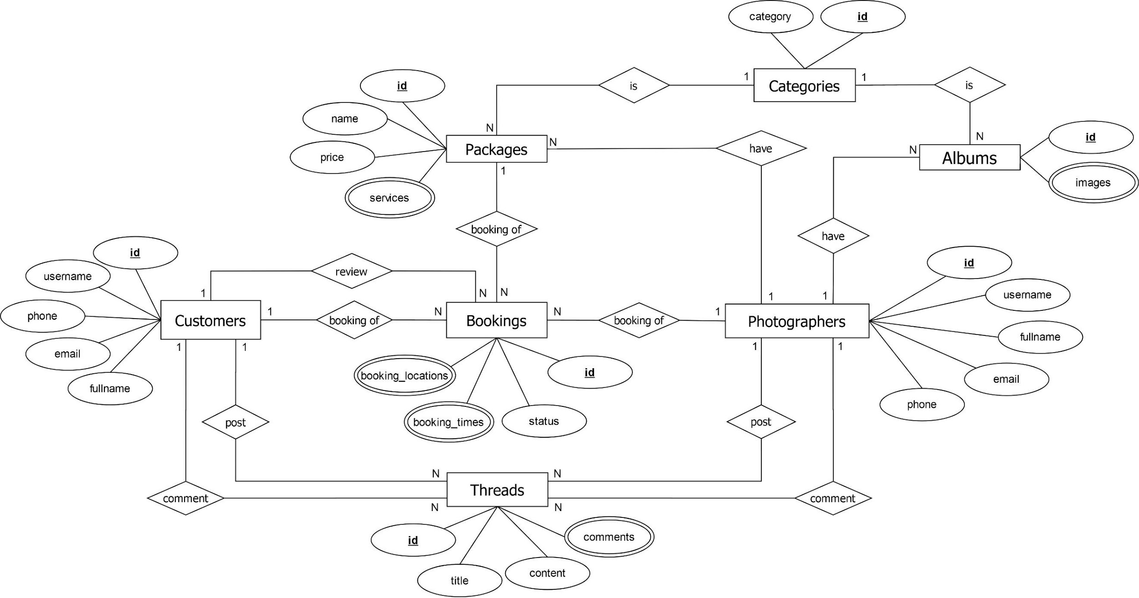

*Figure 54 ER Diagram*

**Entities List**

|  |  |  |
| --- | --- | --- |
| **#** | **Entity** | **Description** |
| 1 | Customer | Customer is an entity representing the person who purchases bookings from photographers: id, username, fullname, phone, email. |
| 2 | Admin | Admin is an entity represents the person who works for pbs system and manages activities of the system: id, username, fullname, phone, email |
| 3 | Booking | Booking is an entity represents the photography deal between photographer and customer: id, status, booking_times, booking_locations |
| 4 | Photographer | Photographer is an entity that represents the person who provides the photography services and takes customers’ deals. |
| 5 | Category | Category is an entity represents the type of albums (is it wedding or look book or anything else): id, category |
| 6 | Album | Album is an entity represents the images which photographer wants to show the customers to attract them: id, images |
| 7 | Package | Package is an entity represents the photography services which photographer provided: id, name, price, services |
| 8 | Thread | Thread is an entity represents a post of photographer or customer or admin on forum: id, title, content, comments |

*Table 49 Entities List*

## 4. Non-Functional Requirements

### 4.1 External Interfaces

#### a. User Interfaces

For web application:

UI-1: GUI has to be simple and easy to use.

UI-2: The language used in the web application is Vietnamese.

UI-3: The web application has to be responsive on multiple devices: laptop, tablet and mobile.

For mobile application:

UI-1: User interface is pleasant to look at and easy to use.

UI-2: The language is Vietnamese.

UI-3: The user interface can be responsive on multiple screen sizes.

UI-4: The functionalities are arranged clearly.

#### b. Software Interfaces

This system will have required software MySQL to program and create and manage the database for the system. Use for source control is Git and GitHub. Test browsers use Chrome 96 or above. Specification for developing the web application is Java EE 11.0.8. Program tools are Visual Studio Code, Android Studio, IntelliJ.

The system will require software window 7 and window 10 to program and manage photographer booking systems. Booking process of the system that organizes the distribution of users in the mobile app and able to do this manage review.

#### c. Hardware Interfaces

Just like any other system, this system requires a basic computer that consists of CPU, monitor, keyboard and mouse or laptop and smartphone for input and output. Smartphones could be used to do booking and use the system. Besides, for direction the system connected with a GPS device in every smartphone to get the location detail.

#### d. Communications Interfaces

The system communication interface is completely dependent on correctly sending and retrieving data from the database. Other than that is an online protocol to connect between GPS and the mobile.

### 4.2 Quality Attributes

#### a. Usability

* The system does not require its users to have any technical knowledge before using its functionalities.
* Layout and navigation are clear and easy to use.
* Customers can use PSB easily even if they have never used it before. They can find a photographer and make a request within 5 minutes.
* Photographers can use PSB easily even if they have never used it before. They can view and confirm requests received from the customers within 5 minutes. They can also use other functionalities quickly and effectively with easy-to-understand instructions and simple operation.

#### b. Reliability

* The availability of the system is 80%. The system can be used within 60 minutes and will automatically log the user out if there is no operation within 5 minutes.

#### c. Performance

All requests will be processed within 10 seconds on an Internet connection above 25Mbps.

#### d. Dependability

##### d1. Security

* All user’s passwords will be encrypted before being saved into the database.
* Accounts will be verified by email.
* Username must be unique.
* Photographers’ email and phone number will be secured.

##### d2. Safety

* A service price a photographer has posted cannot be changed when a customer chooses that service. If there is a surcharge, it must be negotiated with the customer.
* When the photos return day has come, if the photographer does not return the photos, the request will be cancelled automatically.

#### e. Supportability

* Online bookings in real time: The customer will be able to see all the available dates directly, and make a booking. If there is no further availability on one date, this will be blocked in real time to prevent further bookings.
* Intelligent calendar: An intelligent and easy-to-understand booking or occupancy calendar provides the user with a summary of all bookings, capacity and turnover for the required periods at a glance.
* Online and chat support for booking systems.
* Booking management via smartphone.

#### f. Design Constraints

* The software language is Vietnamese.
* The software process is Scrum.

#### g. Support Documents

The system does not use any references to support document writing.

#### h. Purchased Components

To support the system operation, we have used some third-party services such as:

* Google Map API.
* AWS S3.
* ClimaCell weather api.

## 5. Other Requirements

### 5.1 Messages List

|  |  |  |  |  |
| --- | --- | --- | --- | --- |
| # | Message code | Message Type | Context | Content |
| 1 | MSG01 | In line | There is not any search result | Không có kết quả. |
| 2 | MSG02 | In red, under the text box | Input-required fields are empty | Thông tin này là bắt buộc. |
| 3 | MSG03 | Toast message | Updating asset(s) information successfully | Cập nhật thành công. |
| 4 | MSG04 | Toast message | Adding new asset successfully | Thêm * thành công. |
| 5 | MSG05 | Toast message | Confirming email of asset hand-over is sent successfully | A confirmation email has been sent to {email_address}. |
| 6 | MSG06 | Toast message | Resetting asset information successfully | Thay đổi * thành công |
| 7 | MSG07 | Toast message | Deleting asset information successfully | Xóa * thành công. |
| 8 | MSG08 | In red, under the text box | Input value length > max length | Bạn vui lòng nhập đủ{max_length} ký tự. |
| 9 | MSG09 | In line | Username or password is not correct when clicking sign-in | Thông tin đăng nhập không chính xác. |
| 10 | MSG10 | In line | Password and Confirm password are not matched. | Mật khẩu nhập lại không khớp. |
| 11 | MSG11 | Toast message | Register successfully | Đăng ký thành công |
| 12 | MSG12 | In red, under the text box | Email is invalid | Email mail này không hợp lệ. Vui lòng nhập email khác |
| 13 | MSG13 | In red, under the text box | Username is existing | Tên đăng nhập của bạn đã có người sử dụng. Vui lòng nhập tên khác |
| 14 | MSG14 | Toast message | The customer book photographer successfully. | Gửi yêu cầu thành công. |
| 15 | MSG15 | In red, under the text box | The customer does not choose a calendar and address. | Bạn chưa chọn thông tin. |
| 16 | MSG16 | Notifications | The system sends notifications to the customer when photographers accept requests. | Yêu cầu của bạn đã được xác nhận |
| 17 | MSG17 | Notifications | The system sends notification to the customer when a photographer declines a request. | Yêu cầu của bạn đã bị từ chối. |
| 18 | MSG18 | In red, under the text box | Current password is invalid | Mật khẩu nhập lại chưa chính xác |
| 19 | MSG19 | Toast message | The system shows notifications to the admin when blocking users. | Bạn có muốn khóa người dùng này? |
| 20 | MSG20 | Toast message | The admin block user successfully. | Người dùng đã được khóa thành công. |
| 21 | MSG21 | Toast message | The system sends notifications to the user when the account has been blocked. | Tài khoản của bạn đã bị vi phạm. Vui lòng liên hệ với quản trị viên |
| 22 | MSG22 | Toast message | The system shows notifications to the admin when unblocking the user. | Bạn có muốn mở khóa người dùng này? |
| 23 | MSG23 | Toast message | The system sends notifications to the user when the account has unblocked. | Người dùng đã được mở khóa thành công |
| 24 | MSG24 | In red, under the text box | Information is duplicated | * đã tồn tại. |

*Table 50 Messages List*